Report:

The following was observed and photographed through the telescopes:
Moon – a magnitude -0.116 eclipse occurred at 19:11 UT on 2020 Jan 10. This means the limb of the Moon was about 0.12 lunar diameters outside the edge of the umbra (dark shadow). Although the darkest part of Earth’s shadow did not fall on the Moon, nonetheless, during the middle of the eclipse the reduction in the amount of sunlight reaching the Moon close to the southern limb was enough for the dimming to be noticed with the naked eye and clearly seen in telescopes. From the Moon, an observer(!) would have seen the Sun partially eclipsed by the Earth; the Sun being about 80% obscured.
At mid-eclipse the Moon was at altitude of about 27degrees as seen from Sidmouth and well placed for viewing.

The following photographs were taken:
Camera was fixed at the prime focus (f/6.3) and all 10 photographs were taken with exposure 1/1600sec ISO1600 and approximately 10min intervals.
This was so true variations of brightness on the Moon’s surface could be compared between the frames. Unfortunately, a few frames showed some temporary darkening due to thin high cloud occasionally passing in front of the Moon. However, the progress of the edge of the Earth’s shadow can be seen moving from approx. 6 o’clock position on the limb through to approx. 3 o’clock position on the limb, over the duration of the eclipse.
The sky clouded over completely just after 20:00UT.
1738UT – waiting for breaks in the cloud!
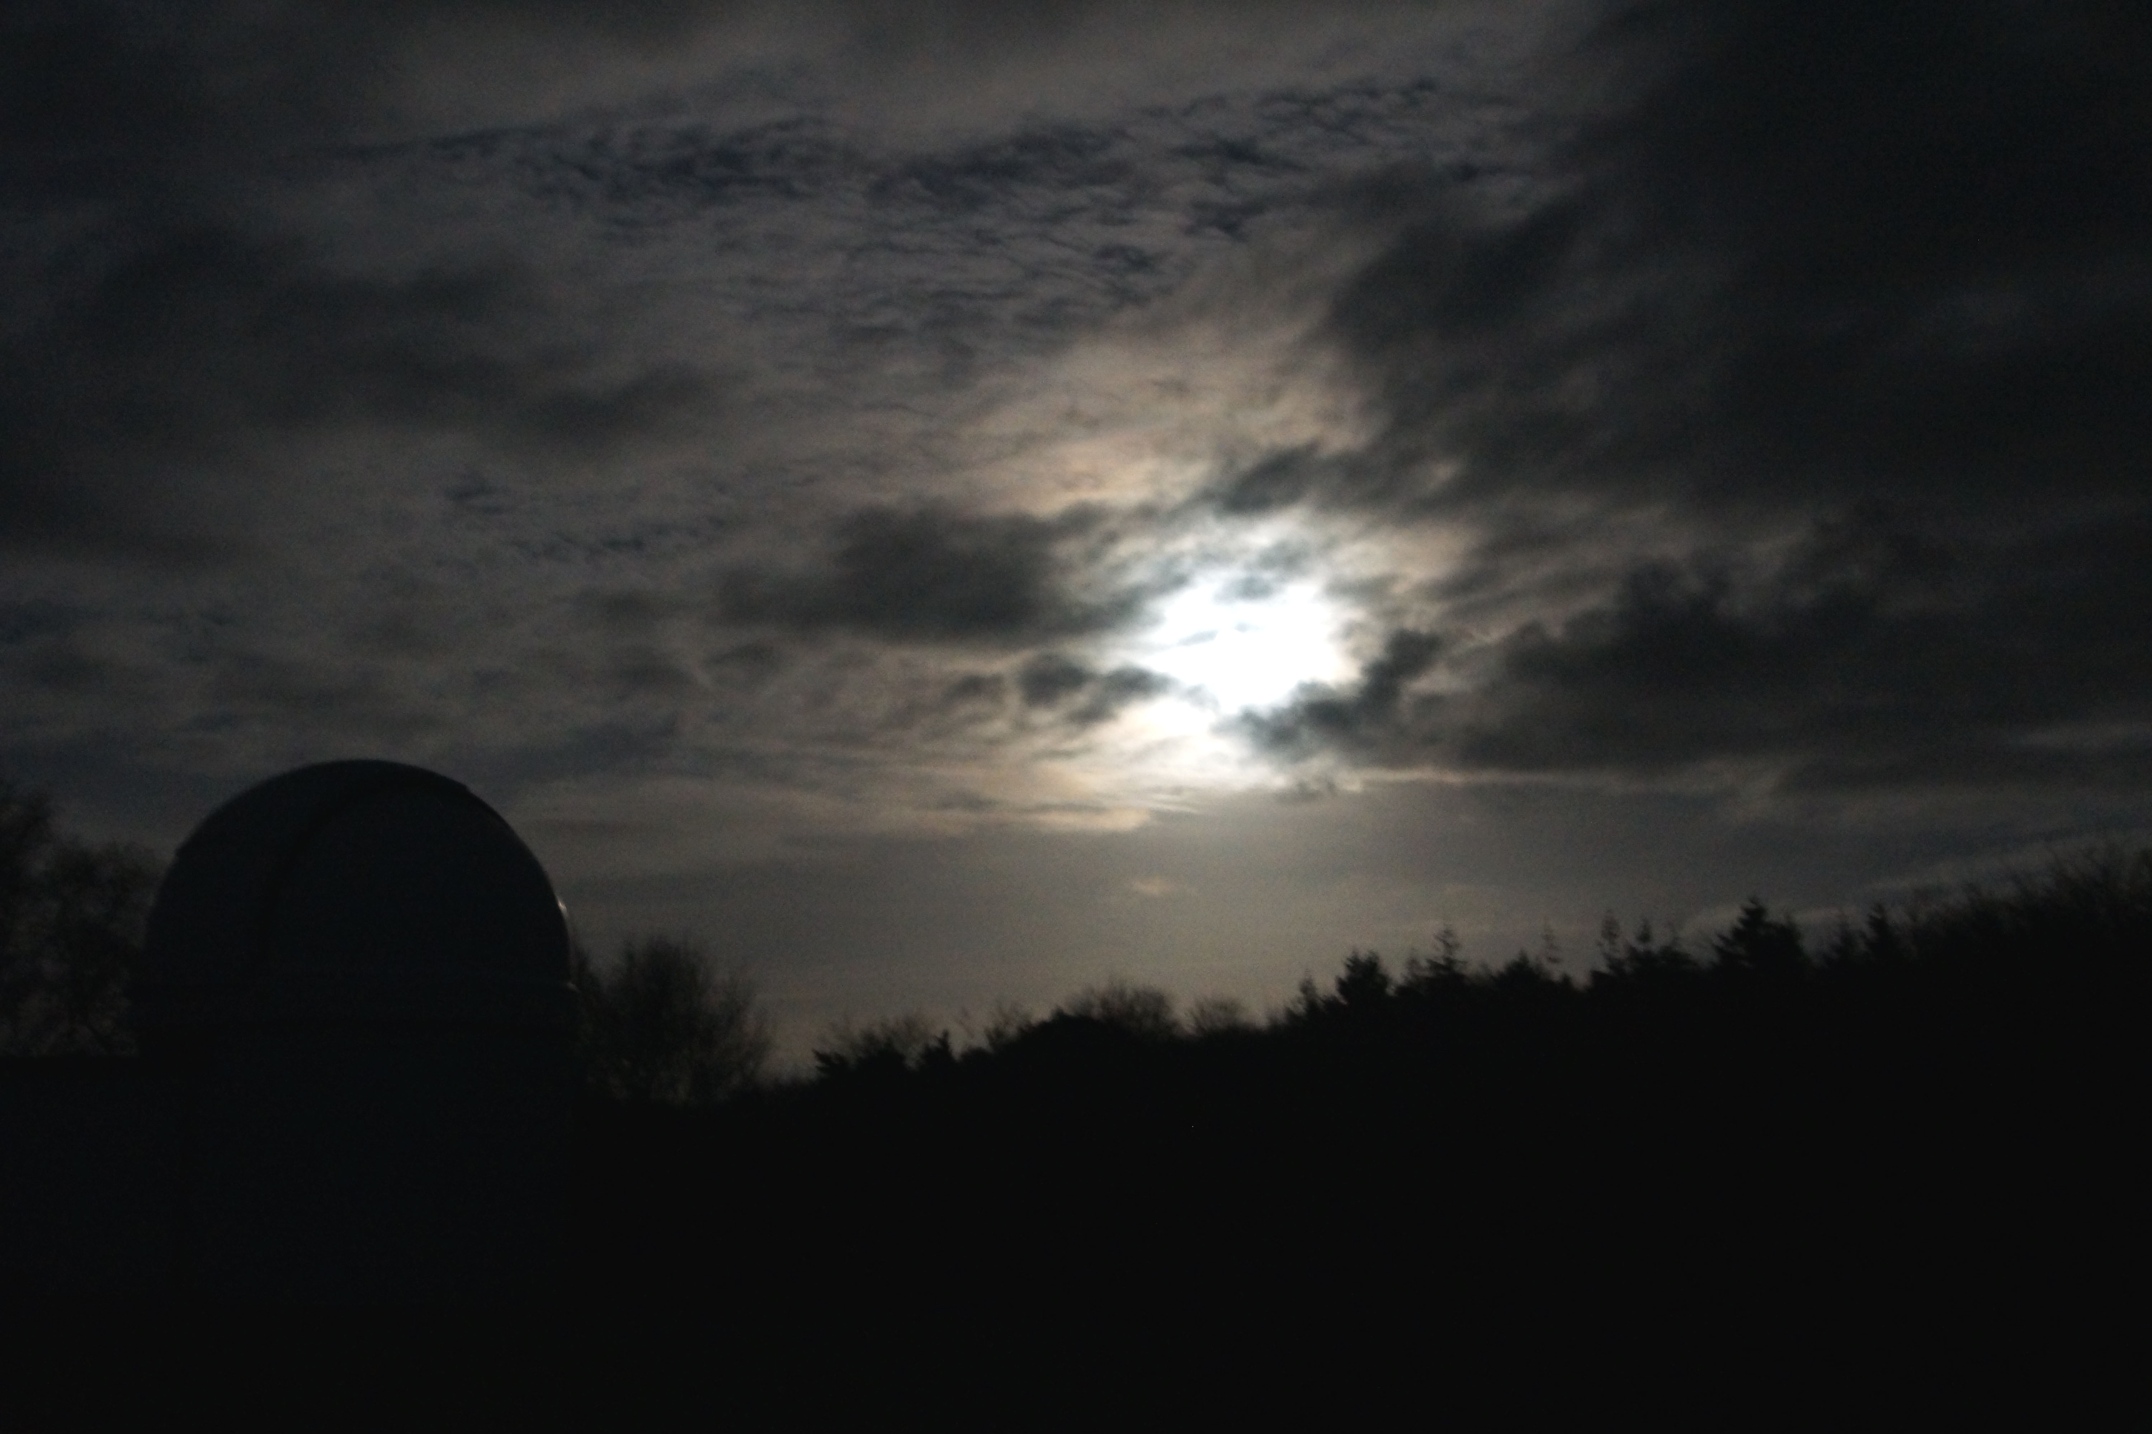

18:29UT
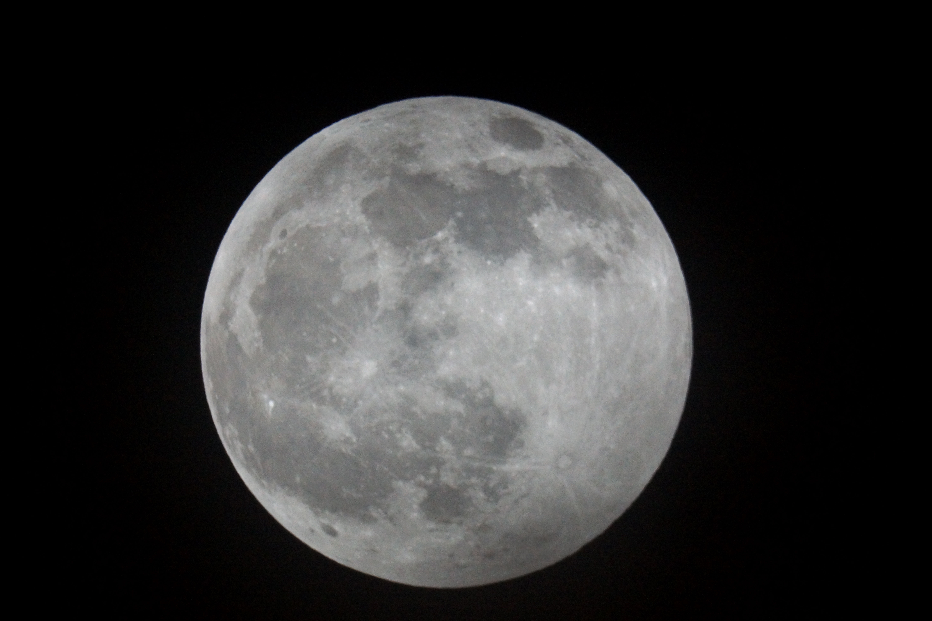
18:40UT
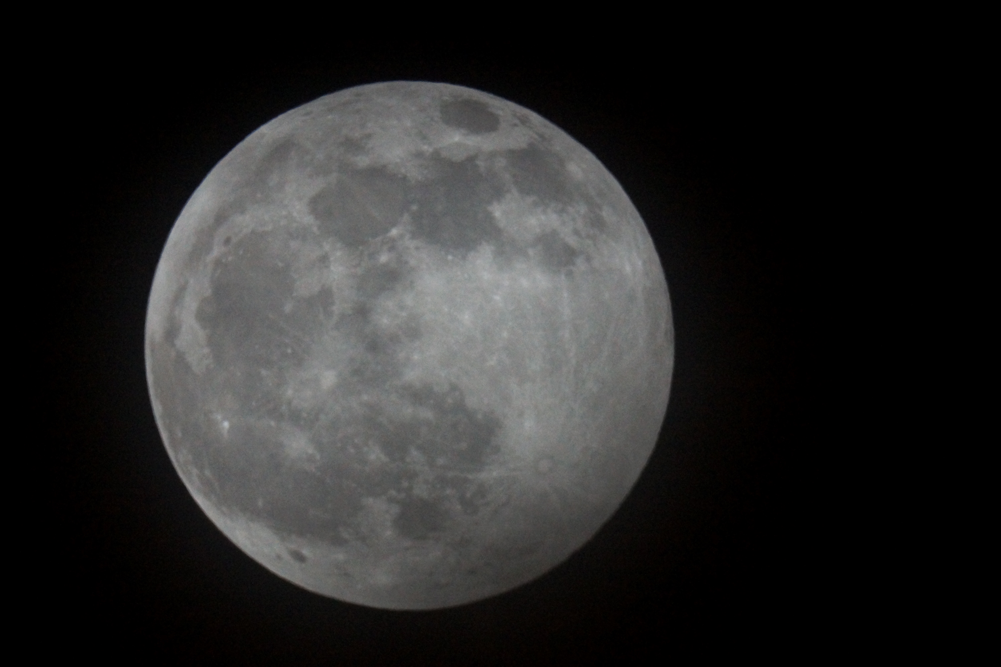
18:50UT
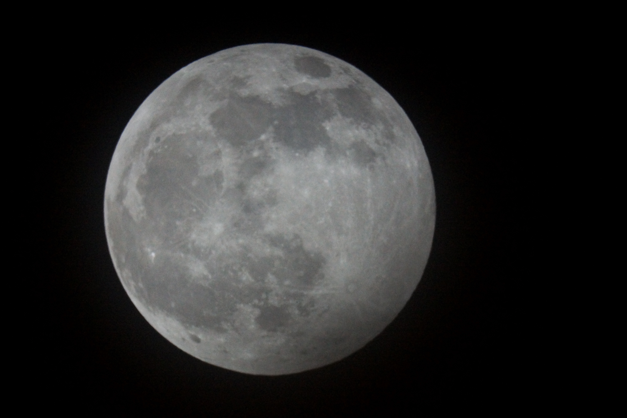

18:57UT
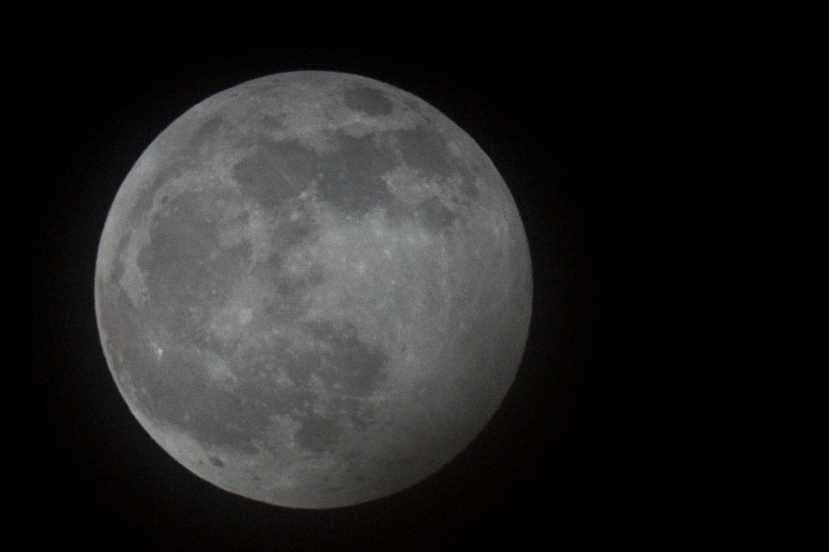

19:07UT
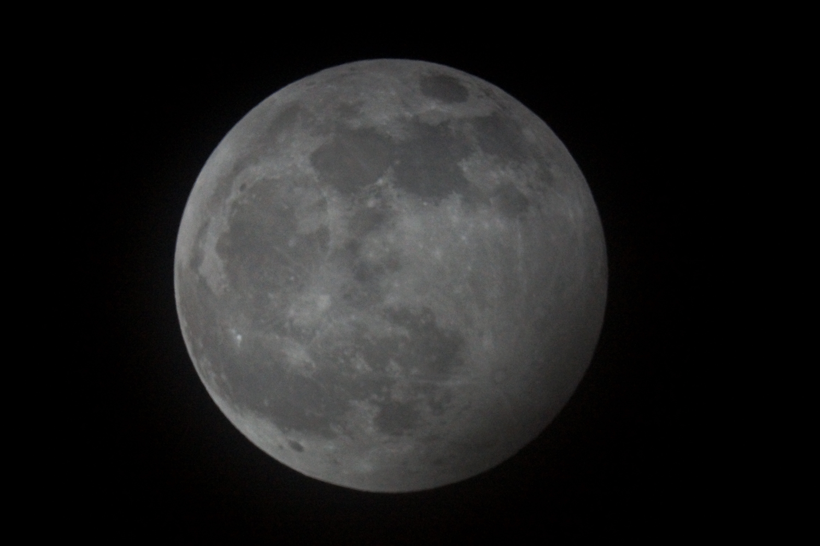
19:12UT
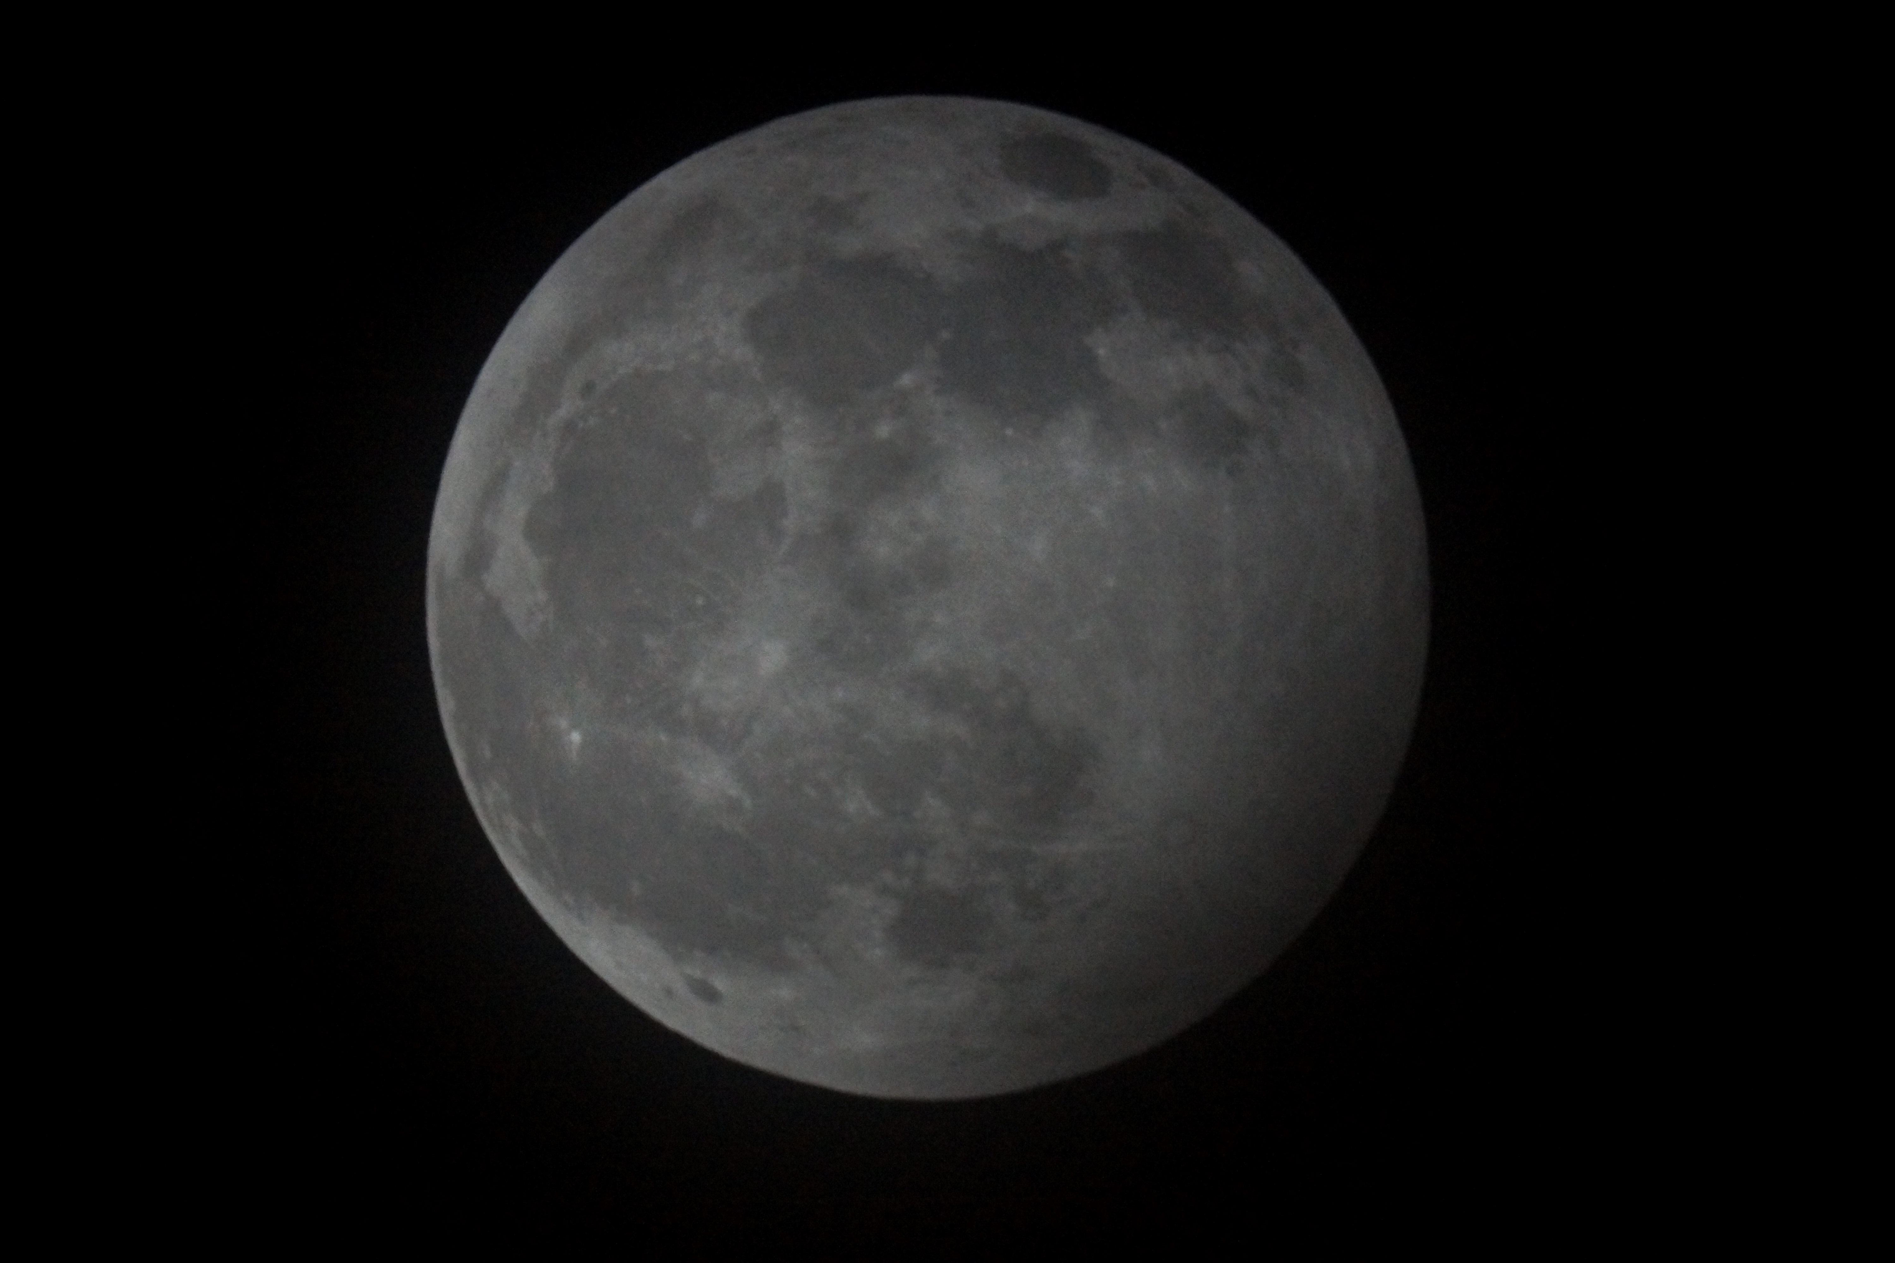
19:22UT
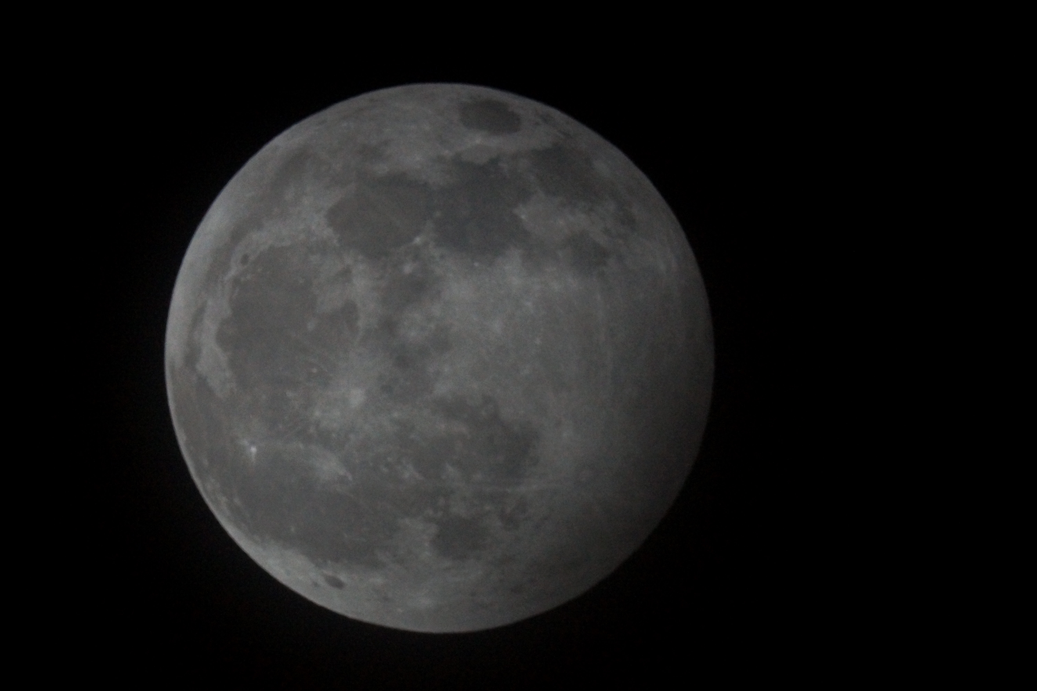
19:33UT
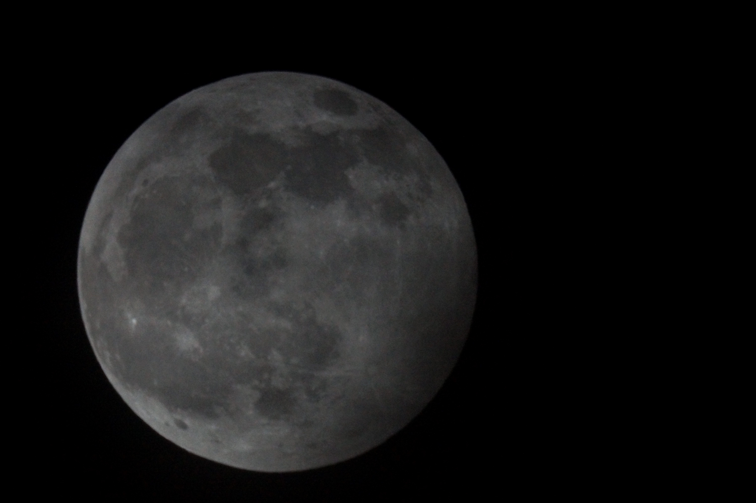
19:45UT
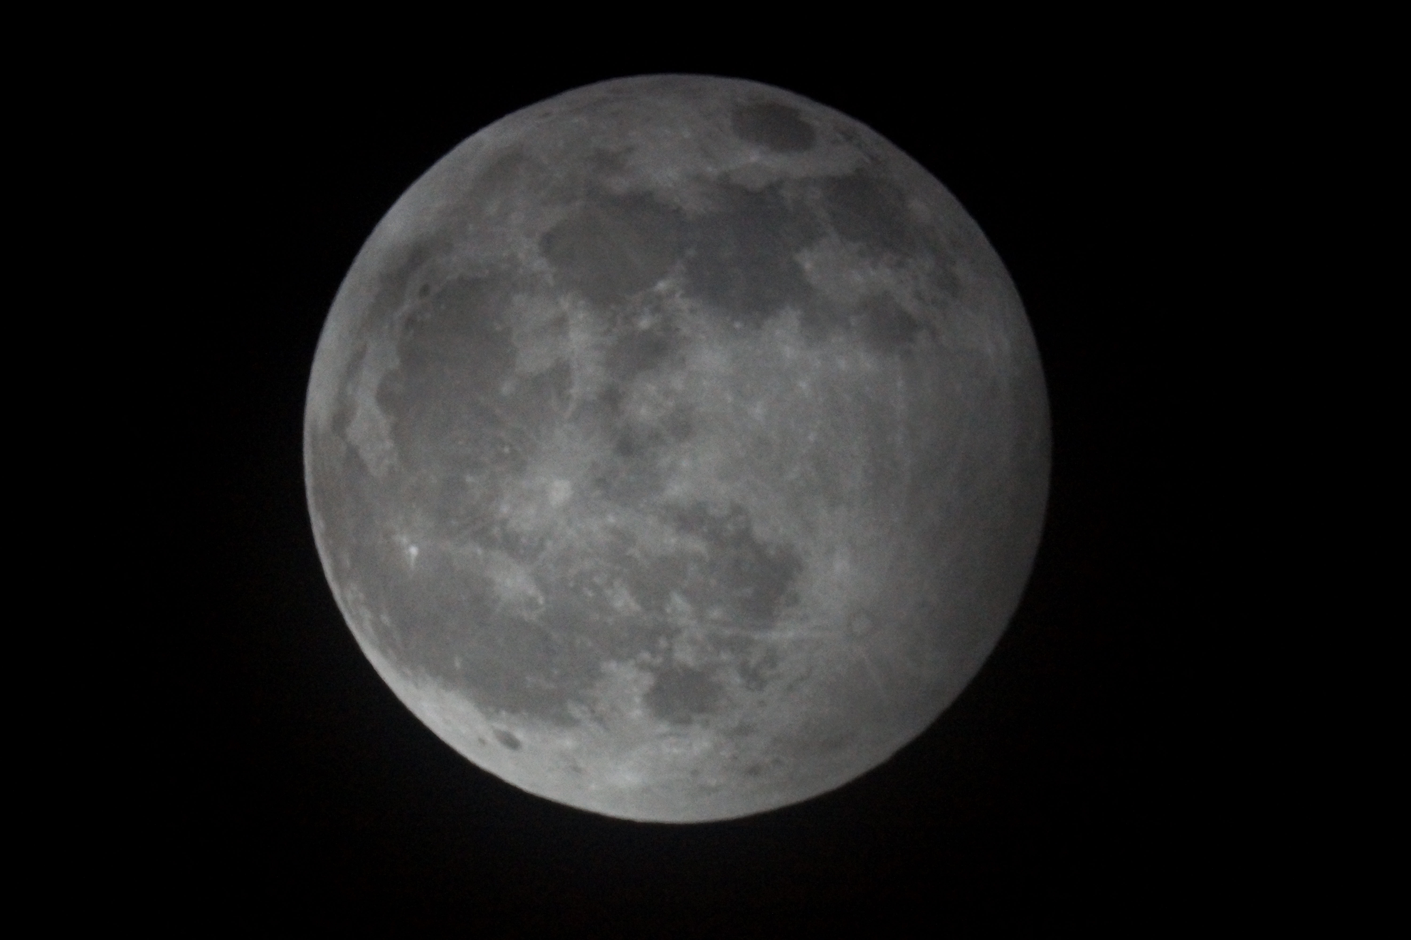
19:55UT
