Report:

The following objects were observed through the telescope:
Moon - First Quarter. Terminator passing through crater Plato - crater floor still in complete darkness but the top of the crater wall was illuminated by the rising sun. Seeing was very steady - allowed use of x400 magnification! Stunning views of Apennine mountain range and crater Archimedes. Also, the ‘Straight Wall’ (Rupes Recta) was very prominent casting a long shadow across the smooth floor of Mare Nubium.
M42 Orion Nebula – The ‘Trapezium’ stars clearly seen although Nebula seemed dim possibly due to strength of the background moonlight.
NGC1981 Open Cluster near Orion Nebula
M1 Crab Nebula in Taurus – faint smudge of light, no detail, difficult to see.
NGC2362 Eskimo Planetary Nebula in Gemini – the gas shell popped in and out of visibility depending on whether you looked directly at it or just to the side of it. Central star seen clearly.
M35 Open Cluster in Gemini
M37 Open Cluster in Auriga
NGC2169 The '37' Open Cluster in Orion (aka ‘The Shopping Trolley’!!)
A few faint (about mag.4) Quadrantid meteors passing above of Leo which was rising in the East.
Betelgeuse - unusually faint - only very slightly brighter than Bellatrix mag.1.6 (estimated Betelgeuse at mag.1.2; it would normally be about mag.0.6)
Rigel - mag.0 double star with mag.7 companion star close by

The following objects were photographed:
I also took a couple of pictures earlier in the evening from Sidmouth Esplanade – Venus in the twilight and the Moon. Both of these were handheld shots.
Venus 35mm zoom f/4.5 1/4sec ISO1600
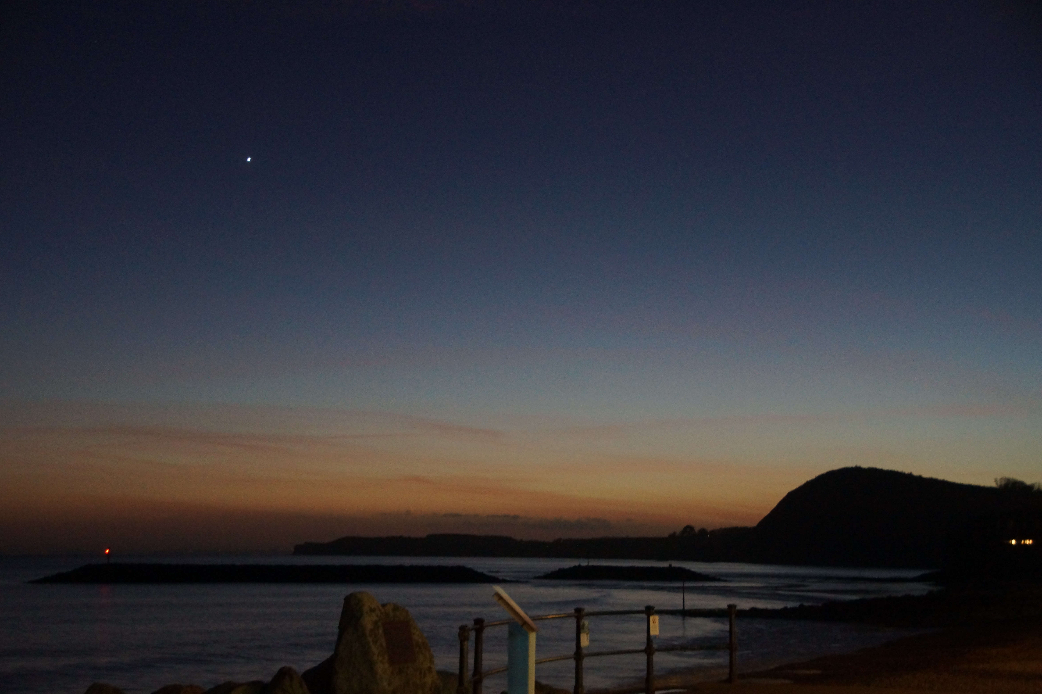
Moon 500mm telephoto f/8 1/3200sec ISO6400
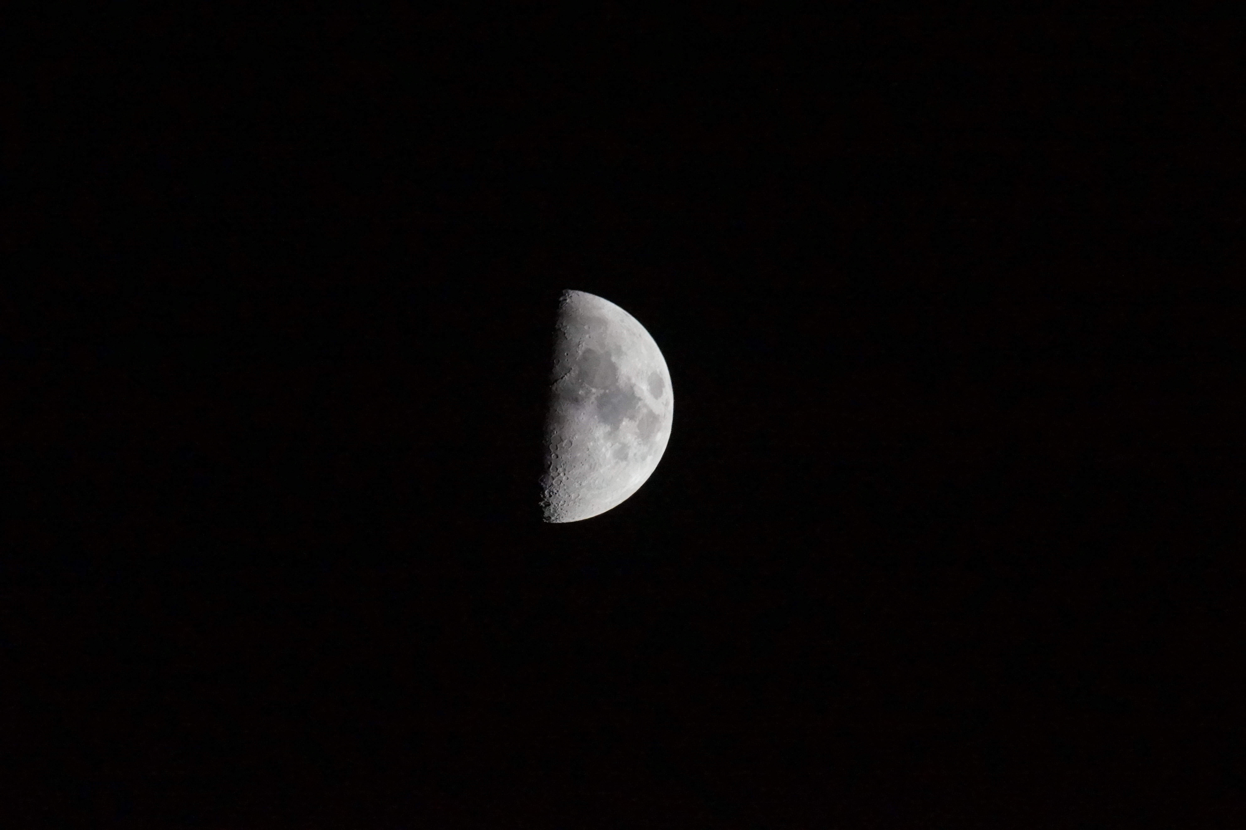

The remaining pictures were with the same DSLR camera & zoom lens on a tripod. I particularly wanted to get some shots of Orion with Betelgeuse in it’s current ‘dimmed’ state. Regardless of whether it goes supernova anytime soon, it is interesting when an object in the sky which we are accustomed to seeing unchanged year after year suddenly does something dramatic and unexpected!
Views West/South/East 18mm zoom f/3.5 4sec ISO3200
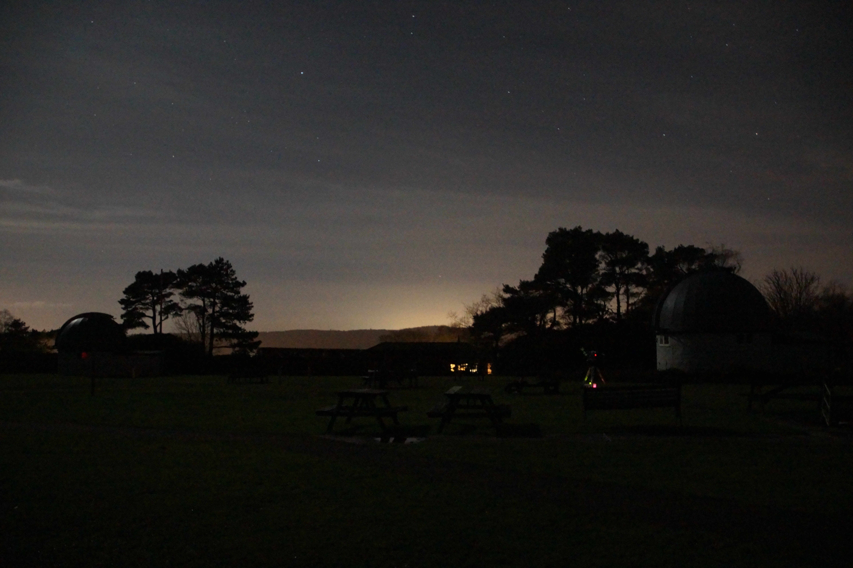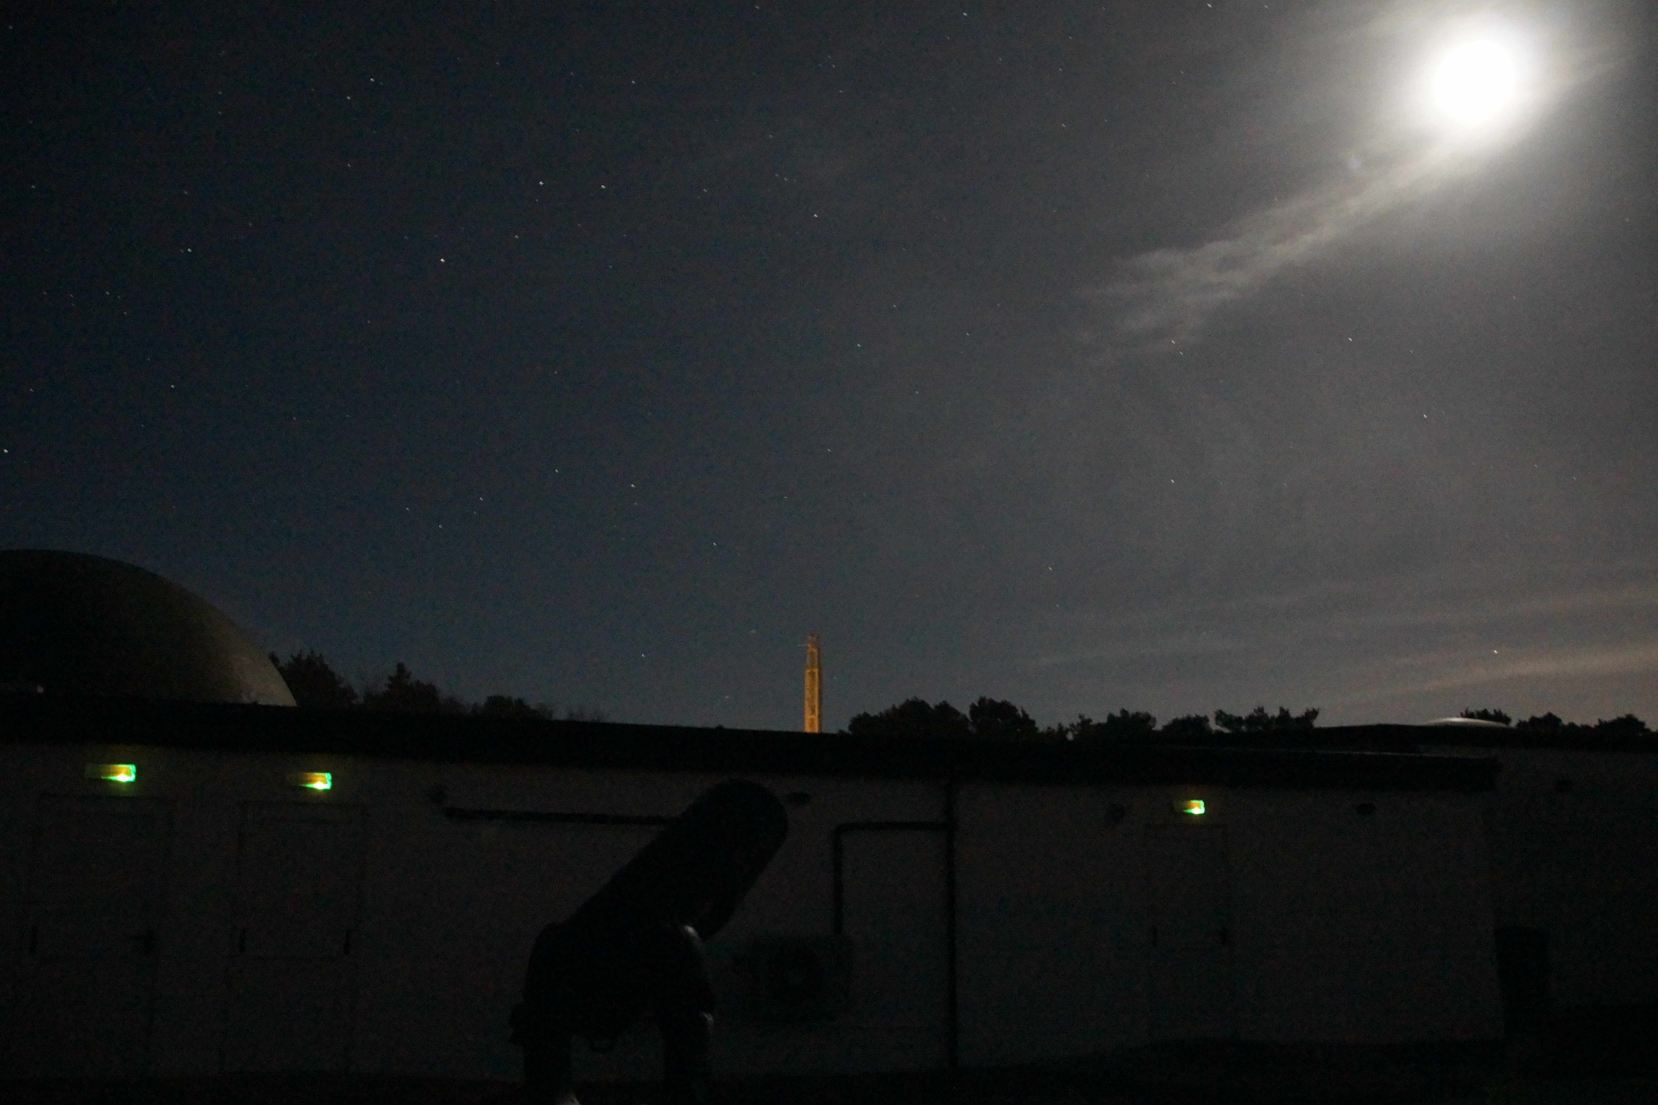
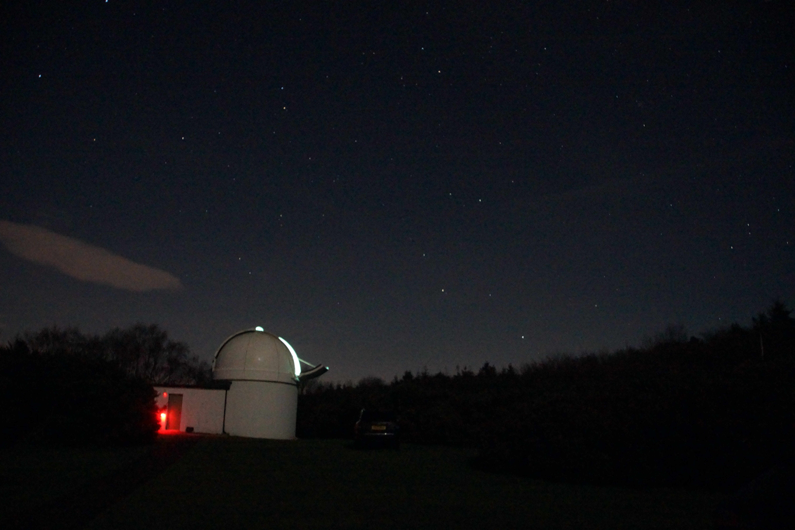
Sword Of Orion 150mm zoom f/6.3 5sec ISO12800
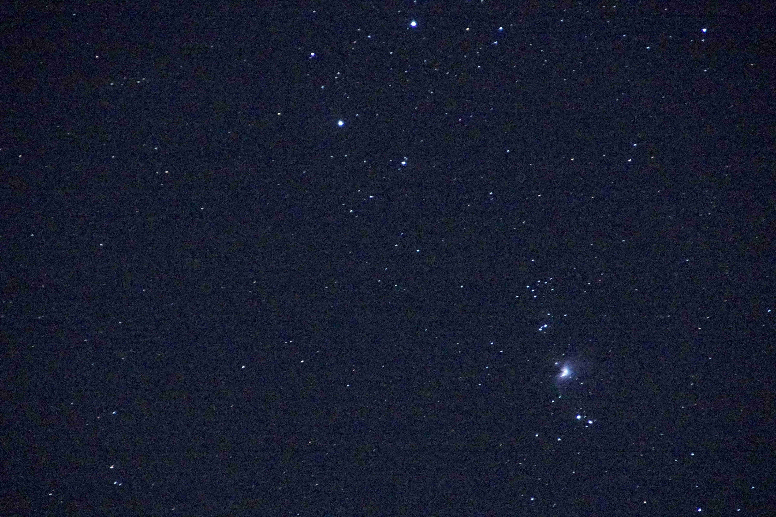
Orion 35mm zoom f/4.5 8sec ISO3200
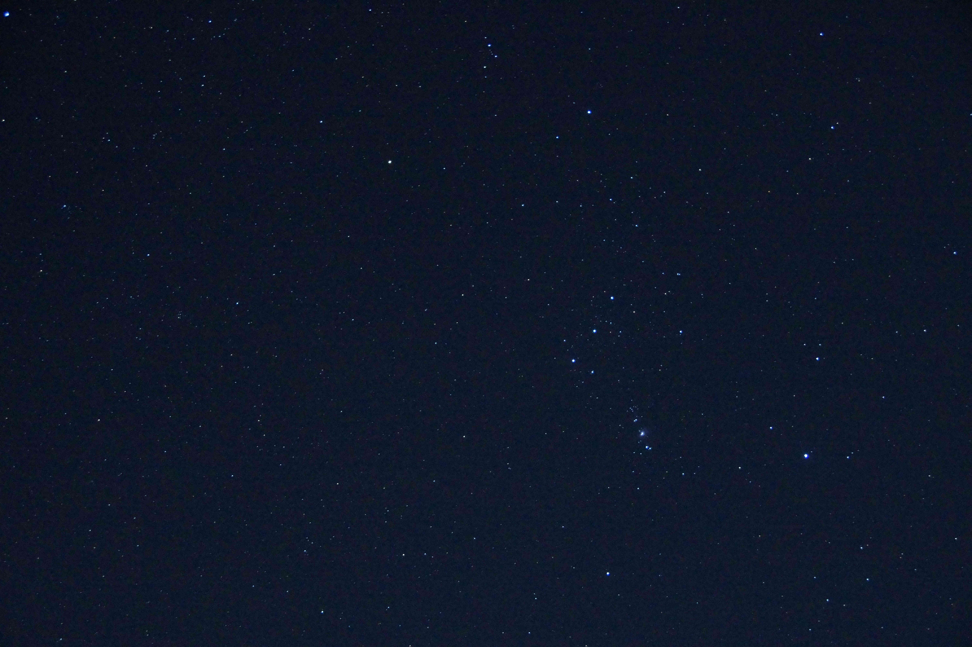

Back in the day (1998!) I did some astrophotography using a manual Fujica STX-1 SLR camera with Tamron lenses using legendary Kodak Ektachrome 400ASA Transparency film – the fastest and best available at the time for astro use. I remembered taking some pictures of Orion then so I thought I would dig them out of my archive and share them here for comparison.
1998 Sword Of Orion 135mm f/2.5 90sec ISO400
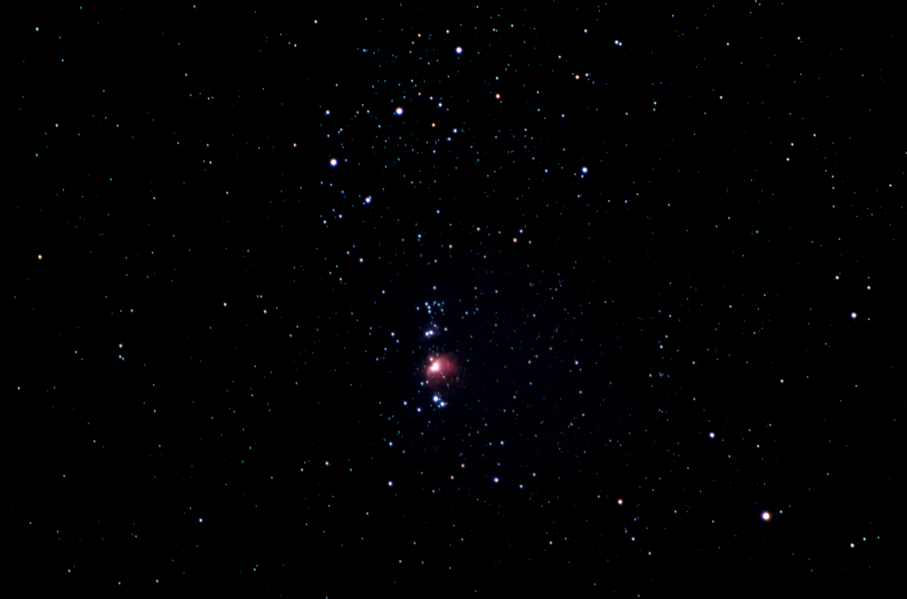
1998 Orion 24mm f/2.5 150sec ISO400
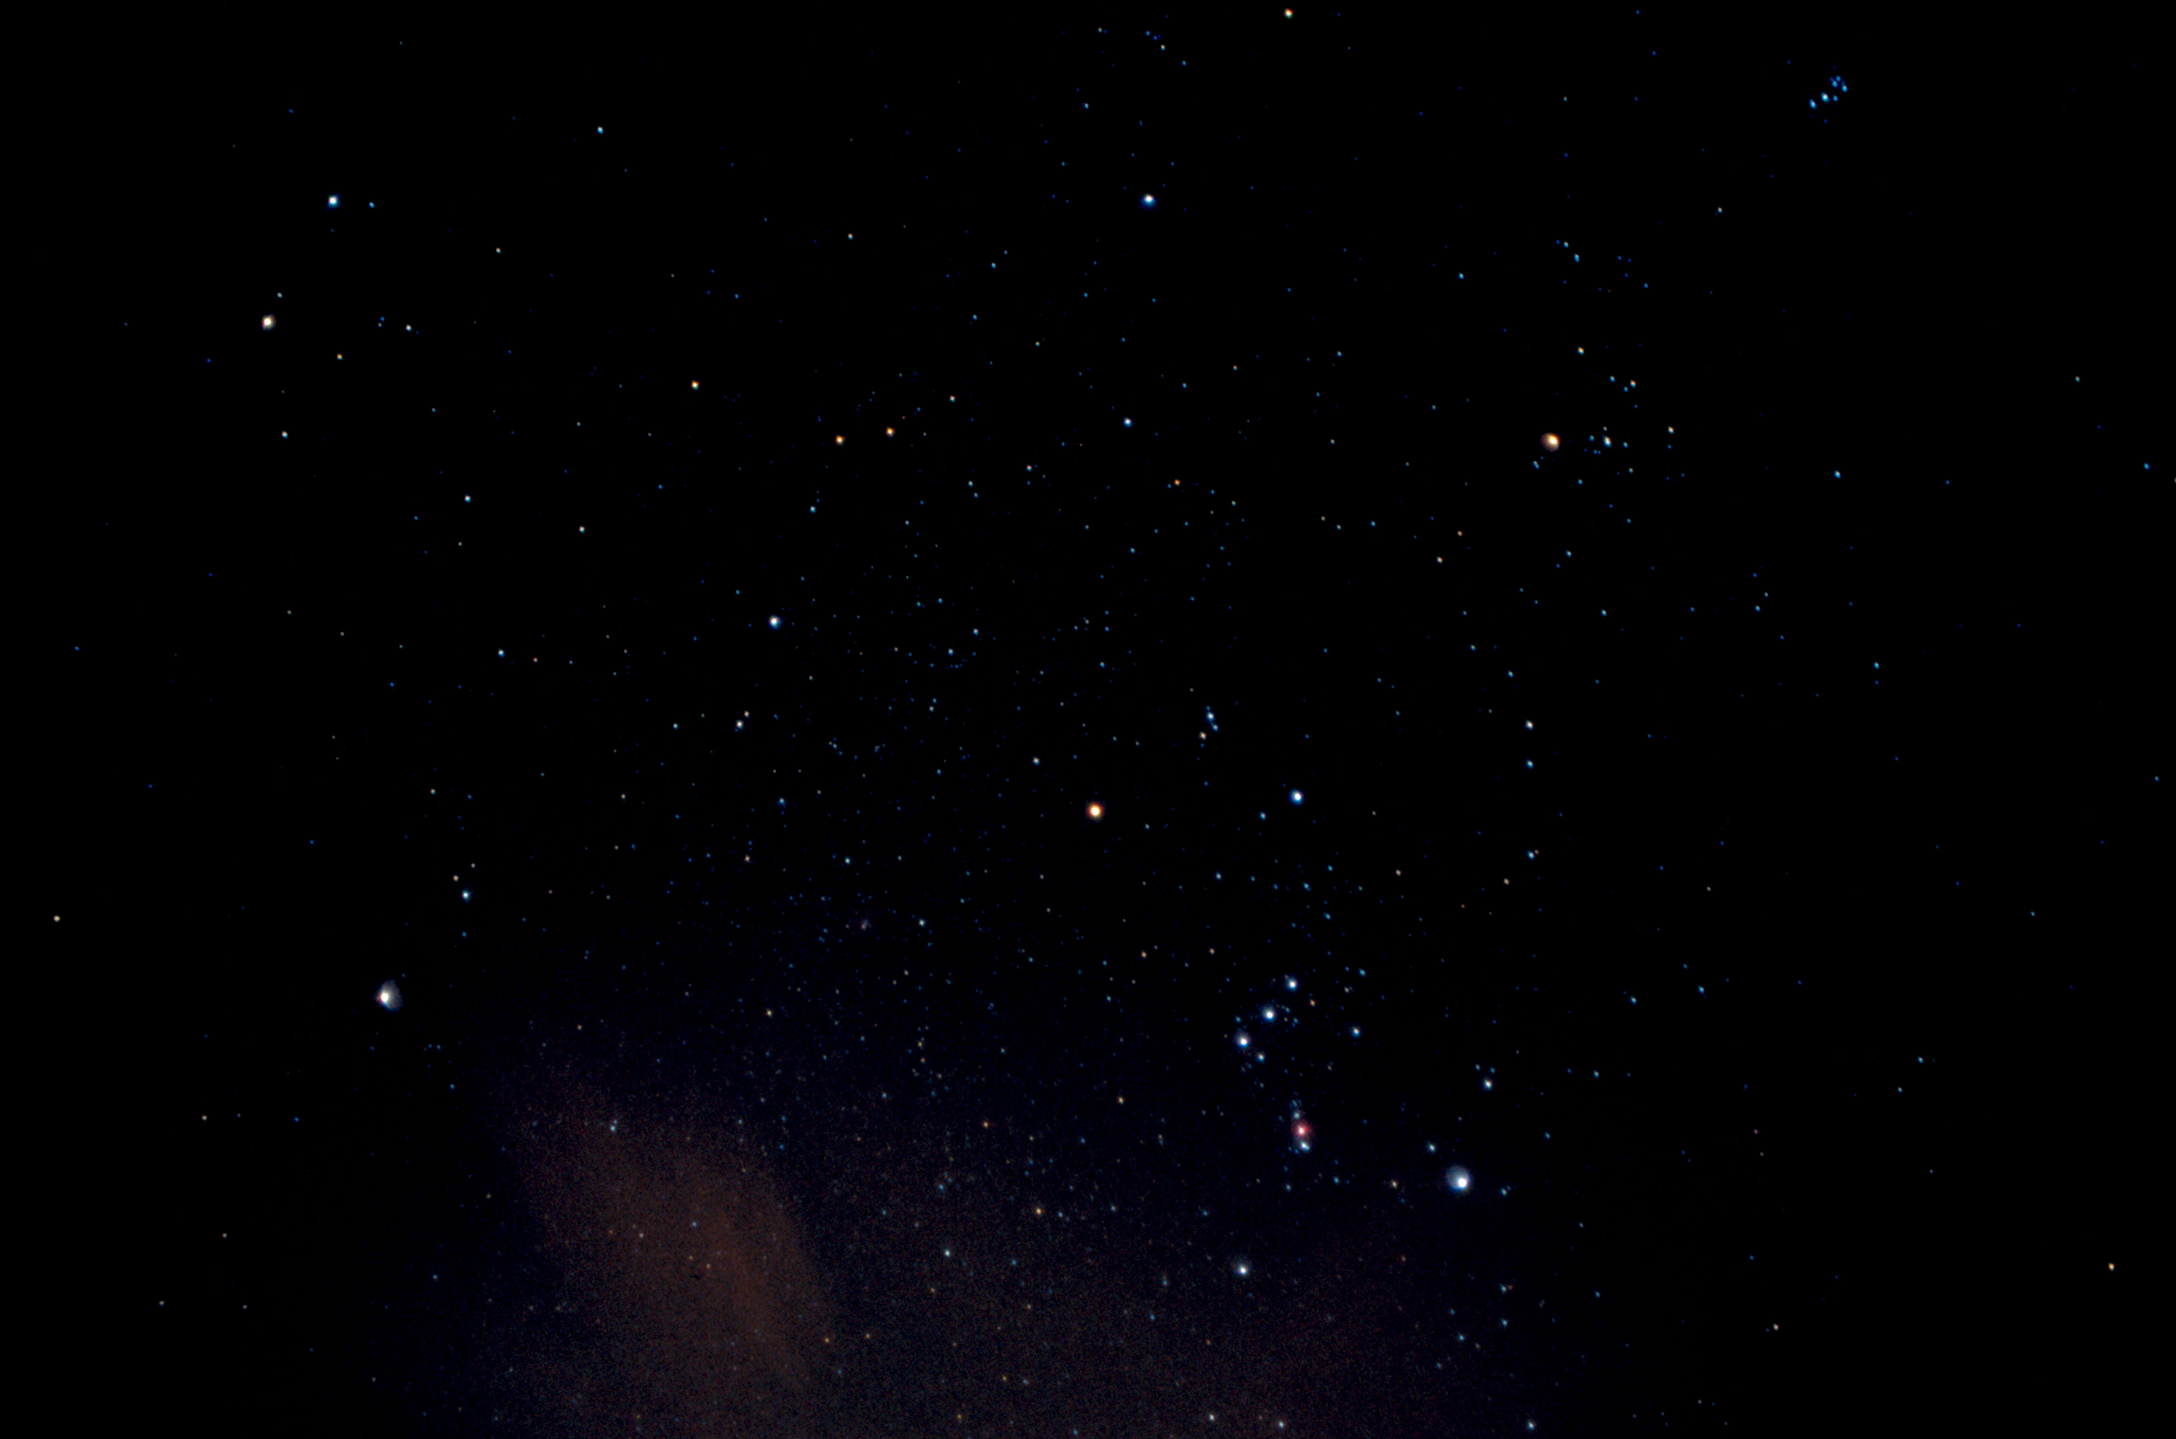

Comparing the shots, Betelgeuse has indeed faded in the past 22 years! It used to be almost as bright as Rigel and now it has faded to almost the brightness of Bellatrix!

