**Report:**

Viewing started at 05:15 – Moon visible intermittently through gaps in cloud; stars in Leo, Cancer and Gemini also visible to the west. Other areas of the sky obscured by mainly low cloud which broke up more as time progressed. Light conditions good; a few streetlights about 200m away which did not interfere. Air was damp and slightly misty.

Manually focussed as auto-focus is unreliable in the dark. Some pictures still came out blurred as modern lenses do not have the same fine focus movement that older lenses had!

Undriven camera on static tripod so I increased ISO speed to keep exposures under 5sec and therefore avoid excessive trailing of moon/stars.

Adjusted manual exposure times based on what looked good through viewfinder!

**The following pictures taken - settings as described against each picture:**

**01**           05:17hrs               ISO6400                5sec            75mm   f/5.6      M44 Praesepe upper left. Clouds clearing. 5min after mid-eclipse.

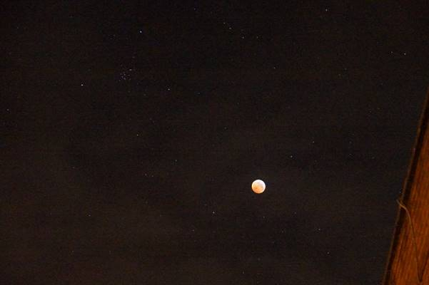

**02**           05:50hrs               ISO3200                3/10sec     500mm f/8          7min after end of totality. Blue tinge due to ozone layer in Earth's atmosphere.

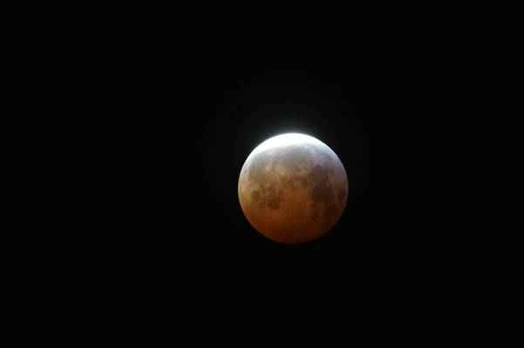

**03**           05:54hrs               ISO3200                1/8sec       500mm f/8          11min after end of totality. Strong blue tinge upper-right edge of moon.

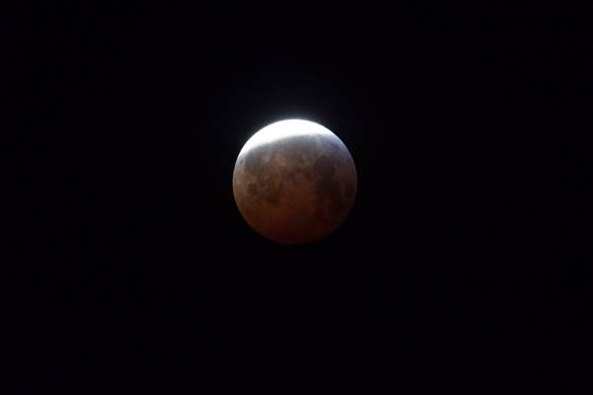

**04**           05:58hrs               ISO3200                3sec            100mm f/5.6      M44 Praesepe upper left. More clouds passing. 15min after end of totality.

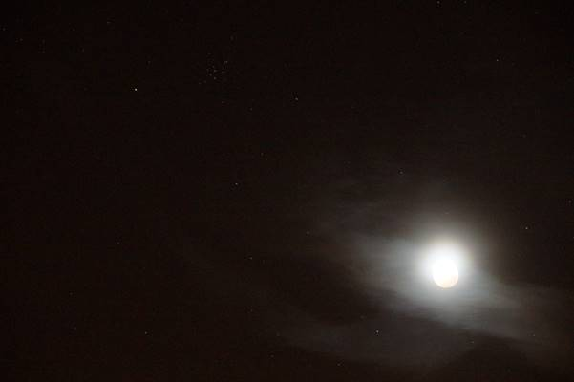

**05**           06:05hrs               ISO3200                1/25sec   500mm f/8          18min after end of totality. Eclipsed area's red colour fades away as bright limb grows.

