Date | 25th Feb 2019 | Time | 19:25 UT
Weather | Clear | Seeing - Antoniadi Scale | II
Location | Back garden (Lat N50 42’, Long W3 4’)
Bortle Scale | 7
Instrument (s) | Skywatcher 150 reflector, 750mm EQ4 mount with drive.  Pictures Nikon D3300 body fitted to telescope using a 2X Barlow Lens.

Report

Observing Conditions

The sky was clear with little disturbance. Two street lamps shone brightly on both sides of the telescope, a tree shaded the telescope from the closest to a limited extent, but it was necessary to shield eyes when using the finder scope, width of view limited due to the street lamps.

Observed the following

Starting at 19:25 UT Orion was visible directly to the South and could be viewed for a short period between the street lamp glare using the telescope. The purpose of the session was to check on how well the mount was able to be set-up for tracking, so a considerable time was spent setting-up although polar alinement check was not possible.

With the equipment set-up as above, a range of exposures and ISO settings were tried when focused on M42, the Orion nebula.

The first two pictures are both cropped 5 second exposures, the first is at 1600 ISO and the second 12800 ISO.

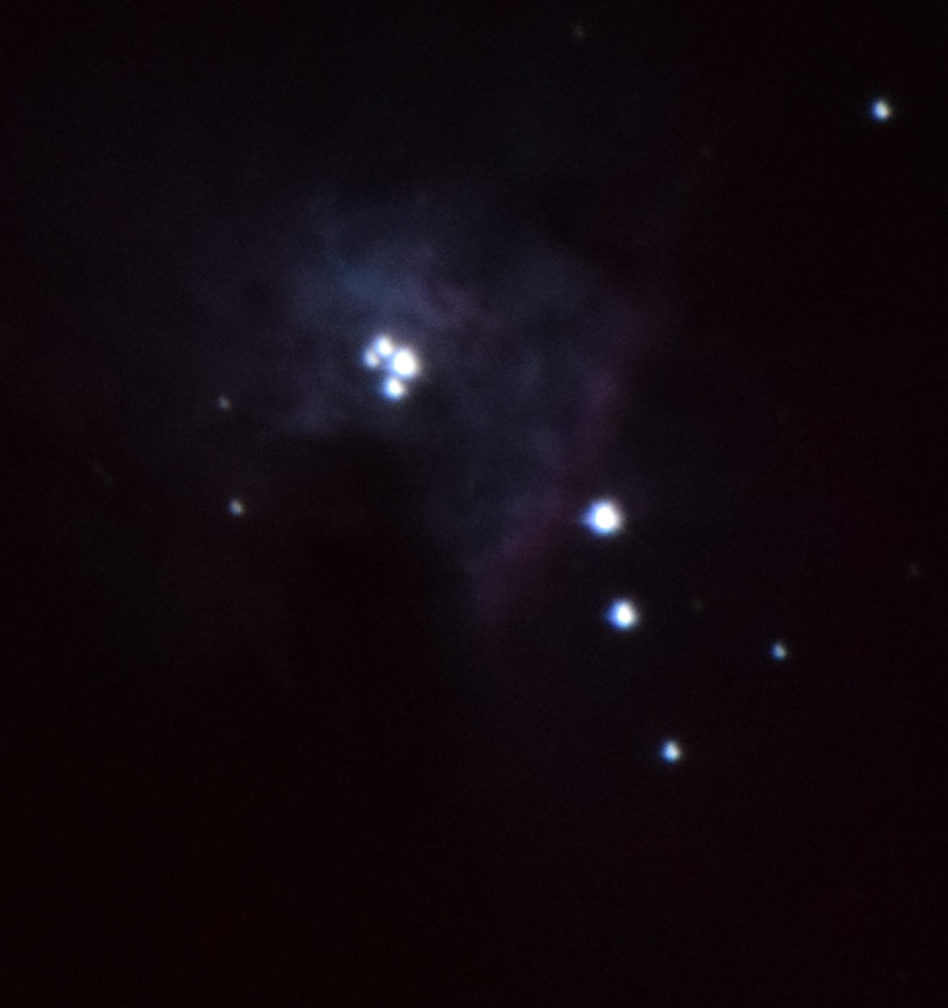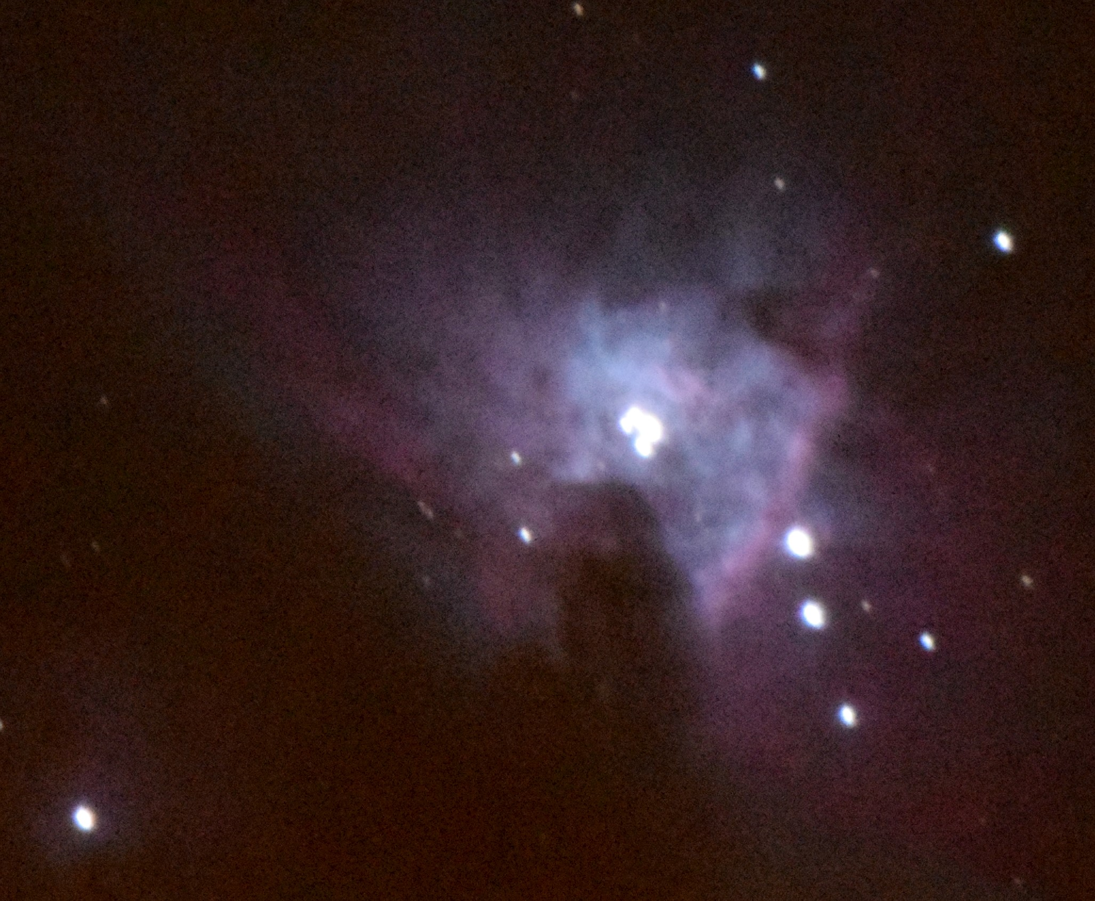

The increase in ISO number clearly shows the increase in detail in the cloud, however this is at the expense of seeing the trapezium in a more blurred clump.

The second two pictures give the same view with an 8 second exposure, first picture 1600 ISO, the second 12800 ISO.

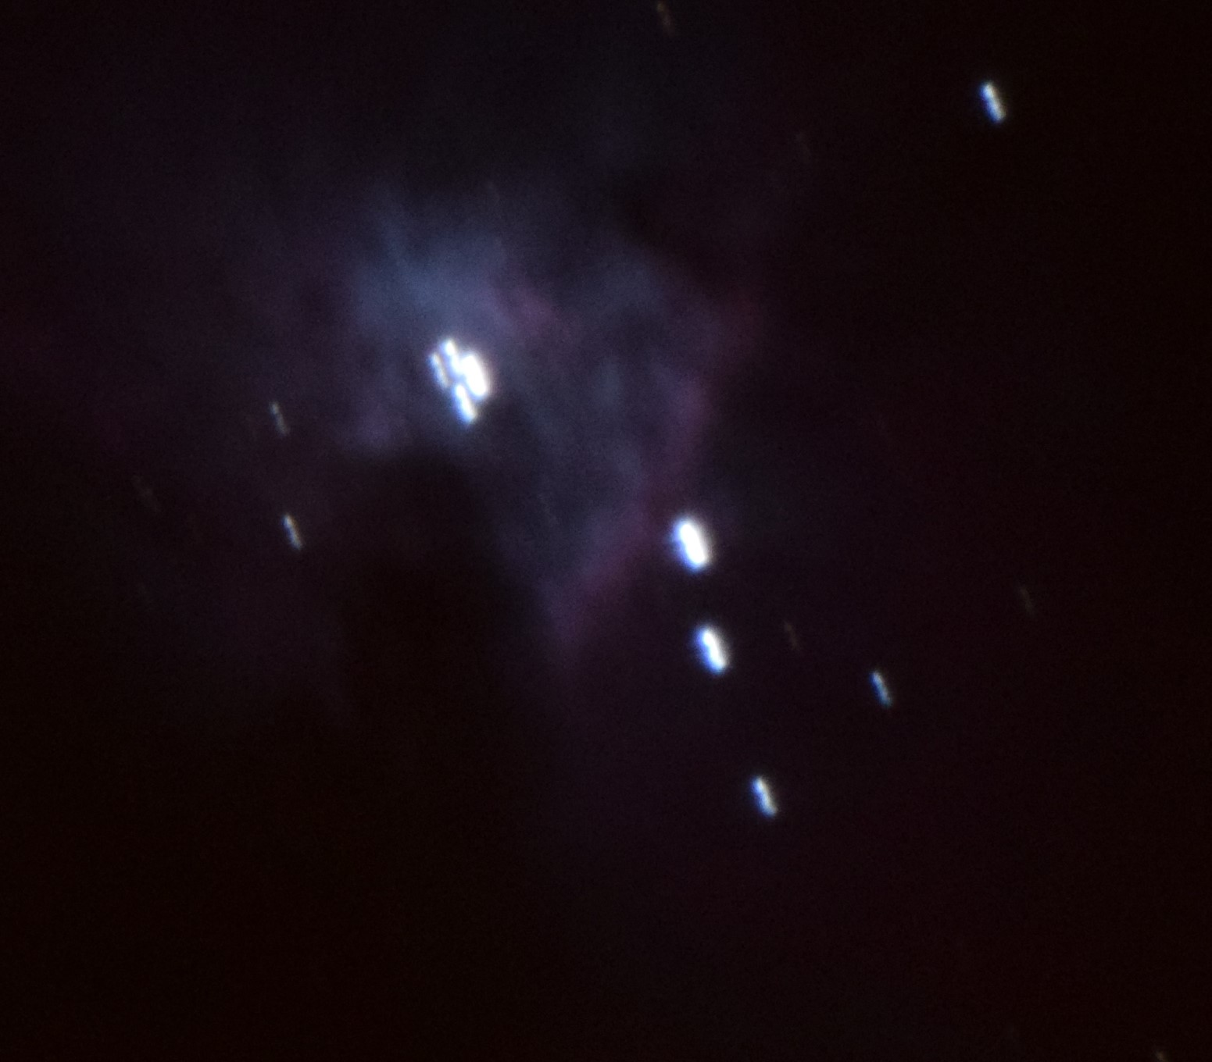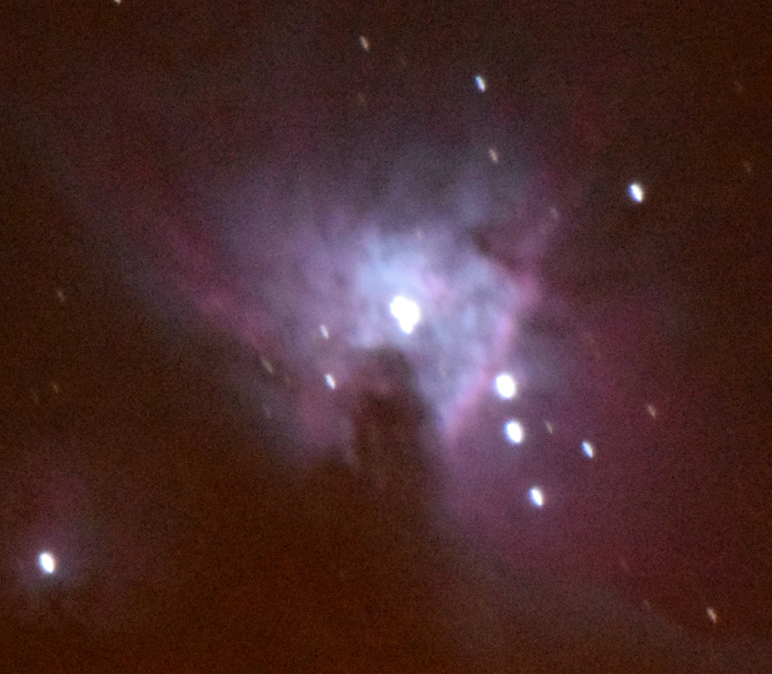

Definitely more star trailing on both pictures.

Result of this indicates that both better setting-up of the mount is required and star tracking is needed for sharper results. The lack of street lights would also be an advantage. At 12800 ISO the picture is definitely picking up a red hue.

Mizar and Alcor

At this time (19:58 UT) the telescope was rotated to view Mizar and Alcor in the plough and see what separation was achieved between this double, the text books provide a resolution of 11’ 49” is required to see them.

The first three pictures were all taken at 12800 ISO setting with exposures of 3, 5 and 2 seconds respectively.

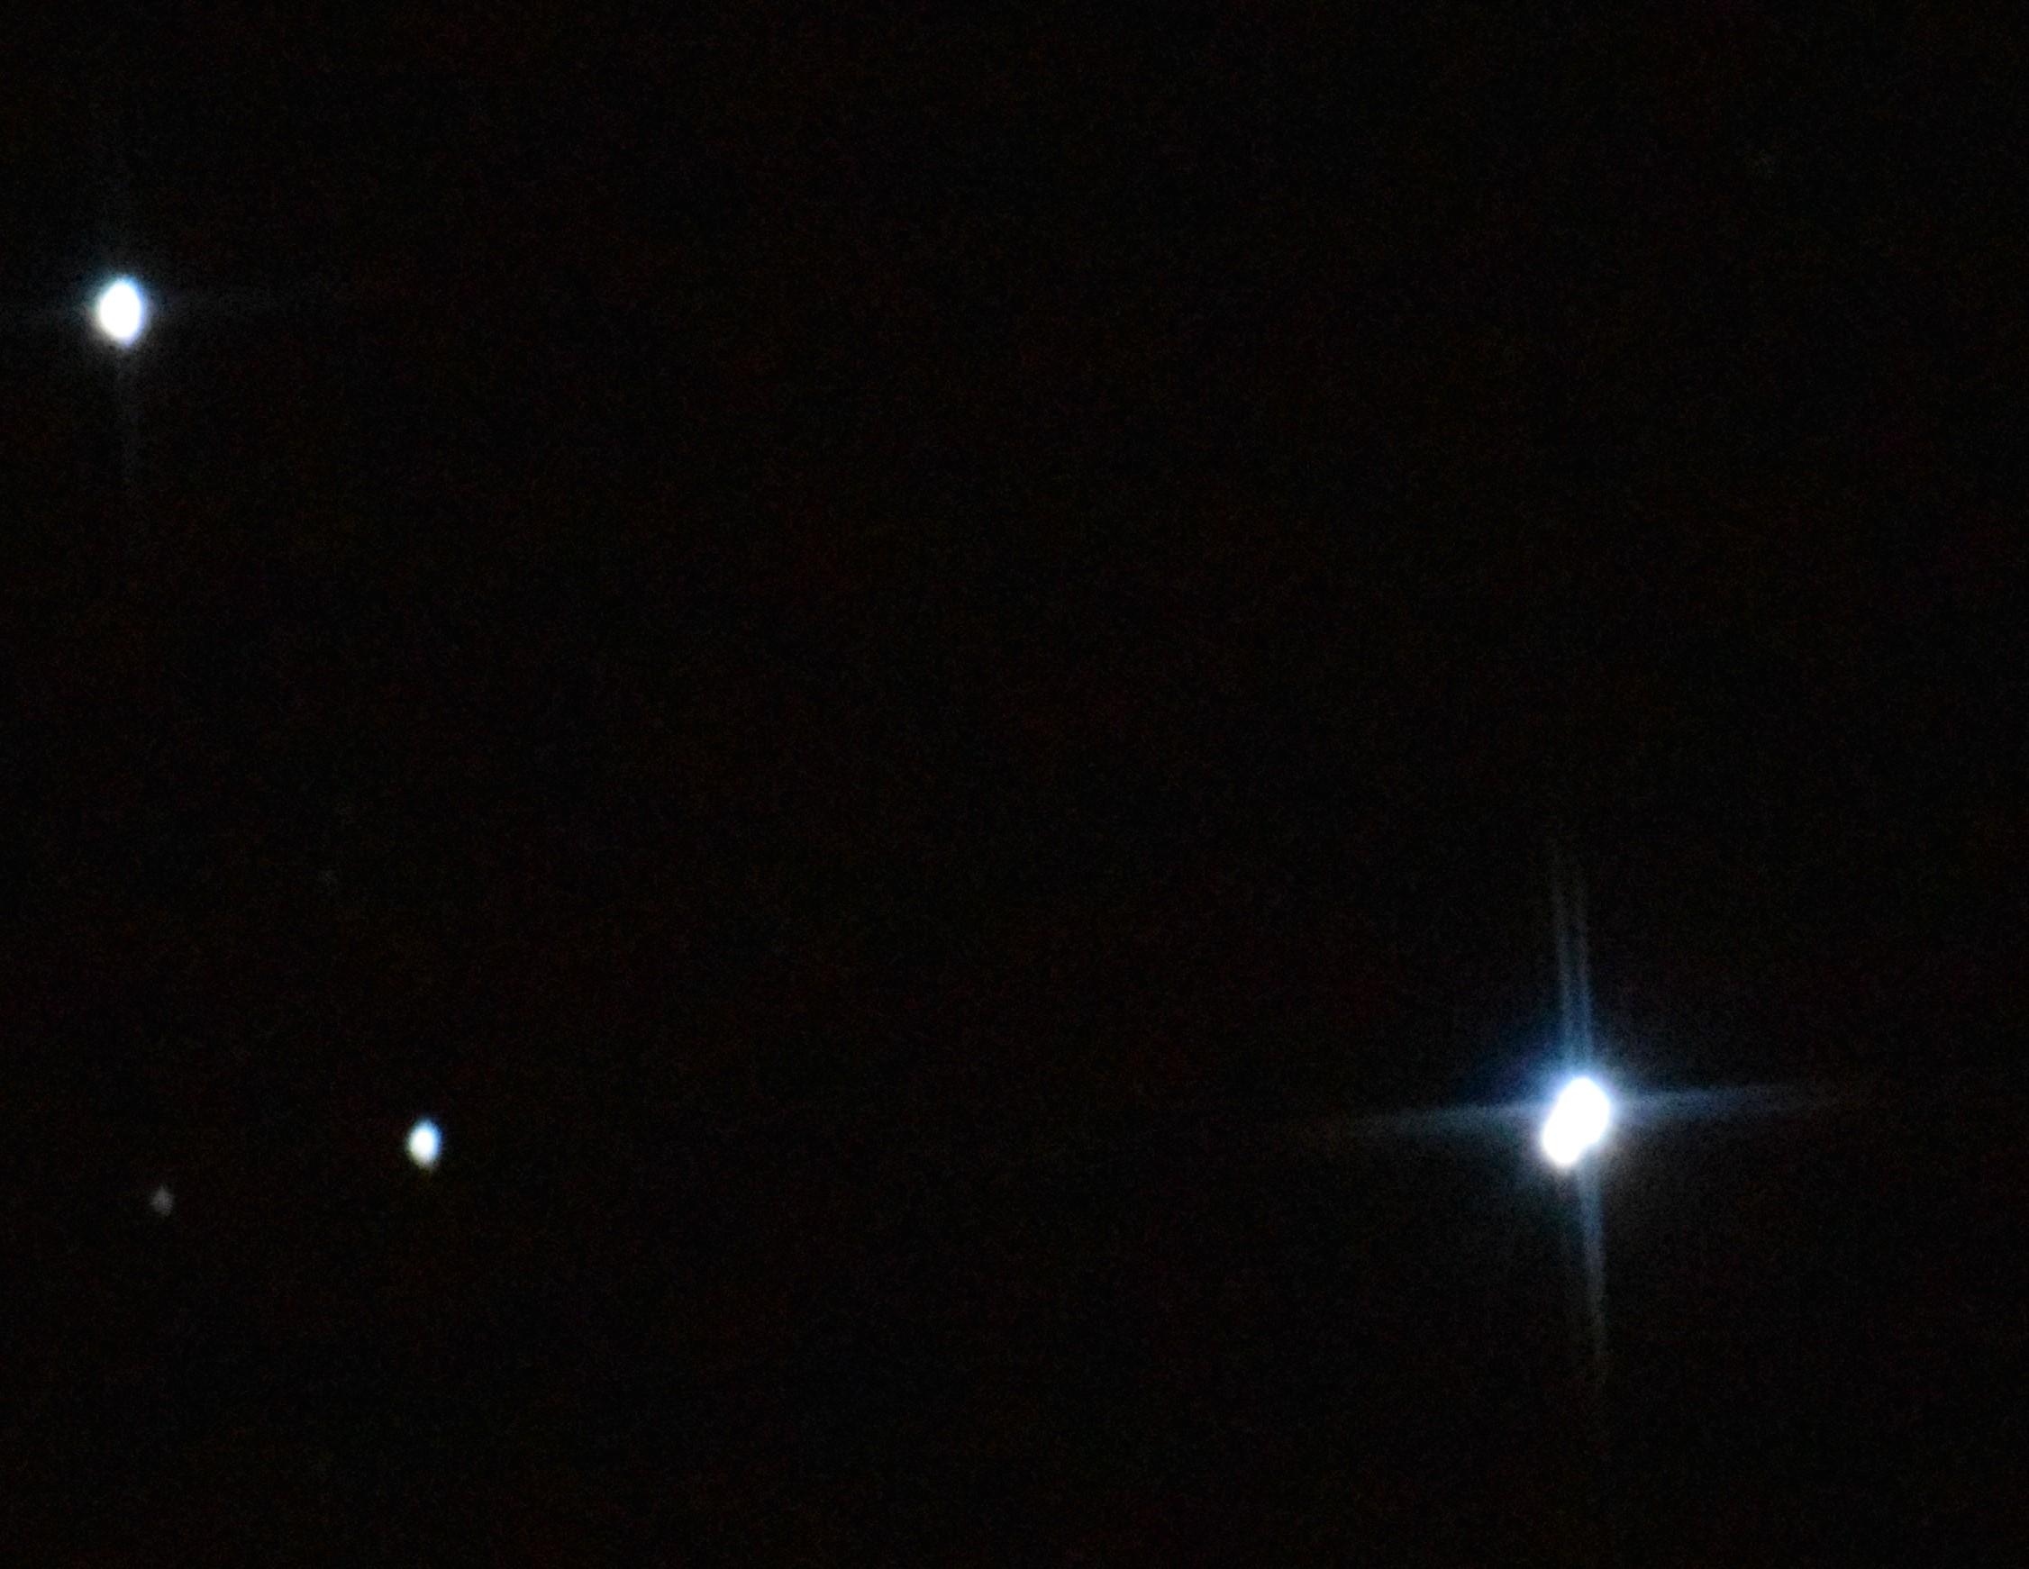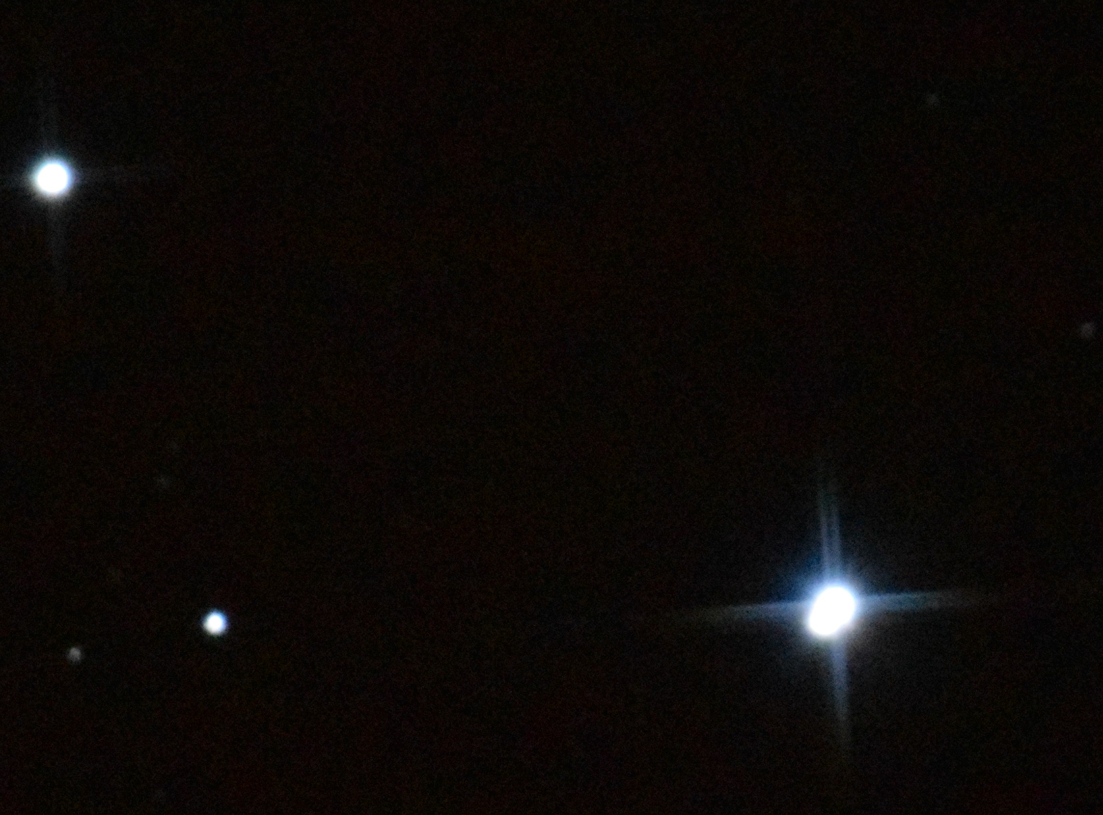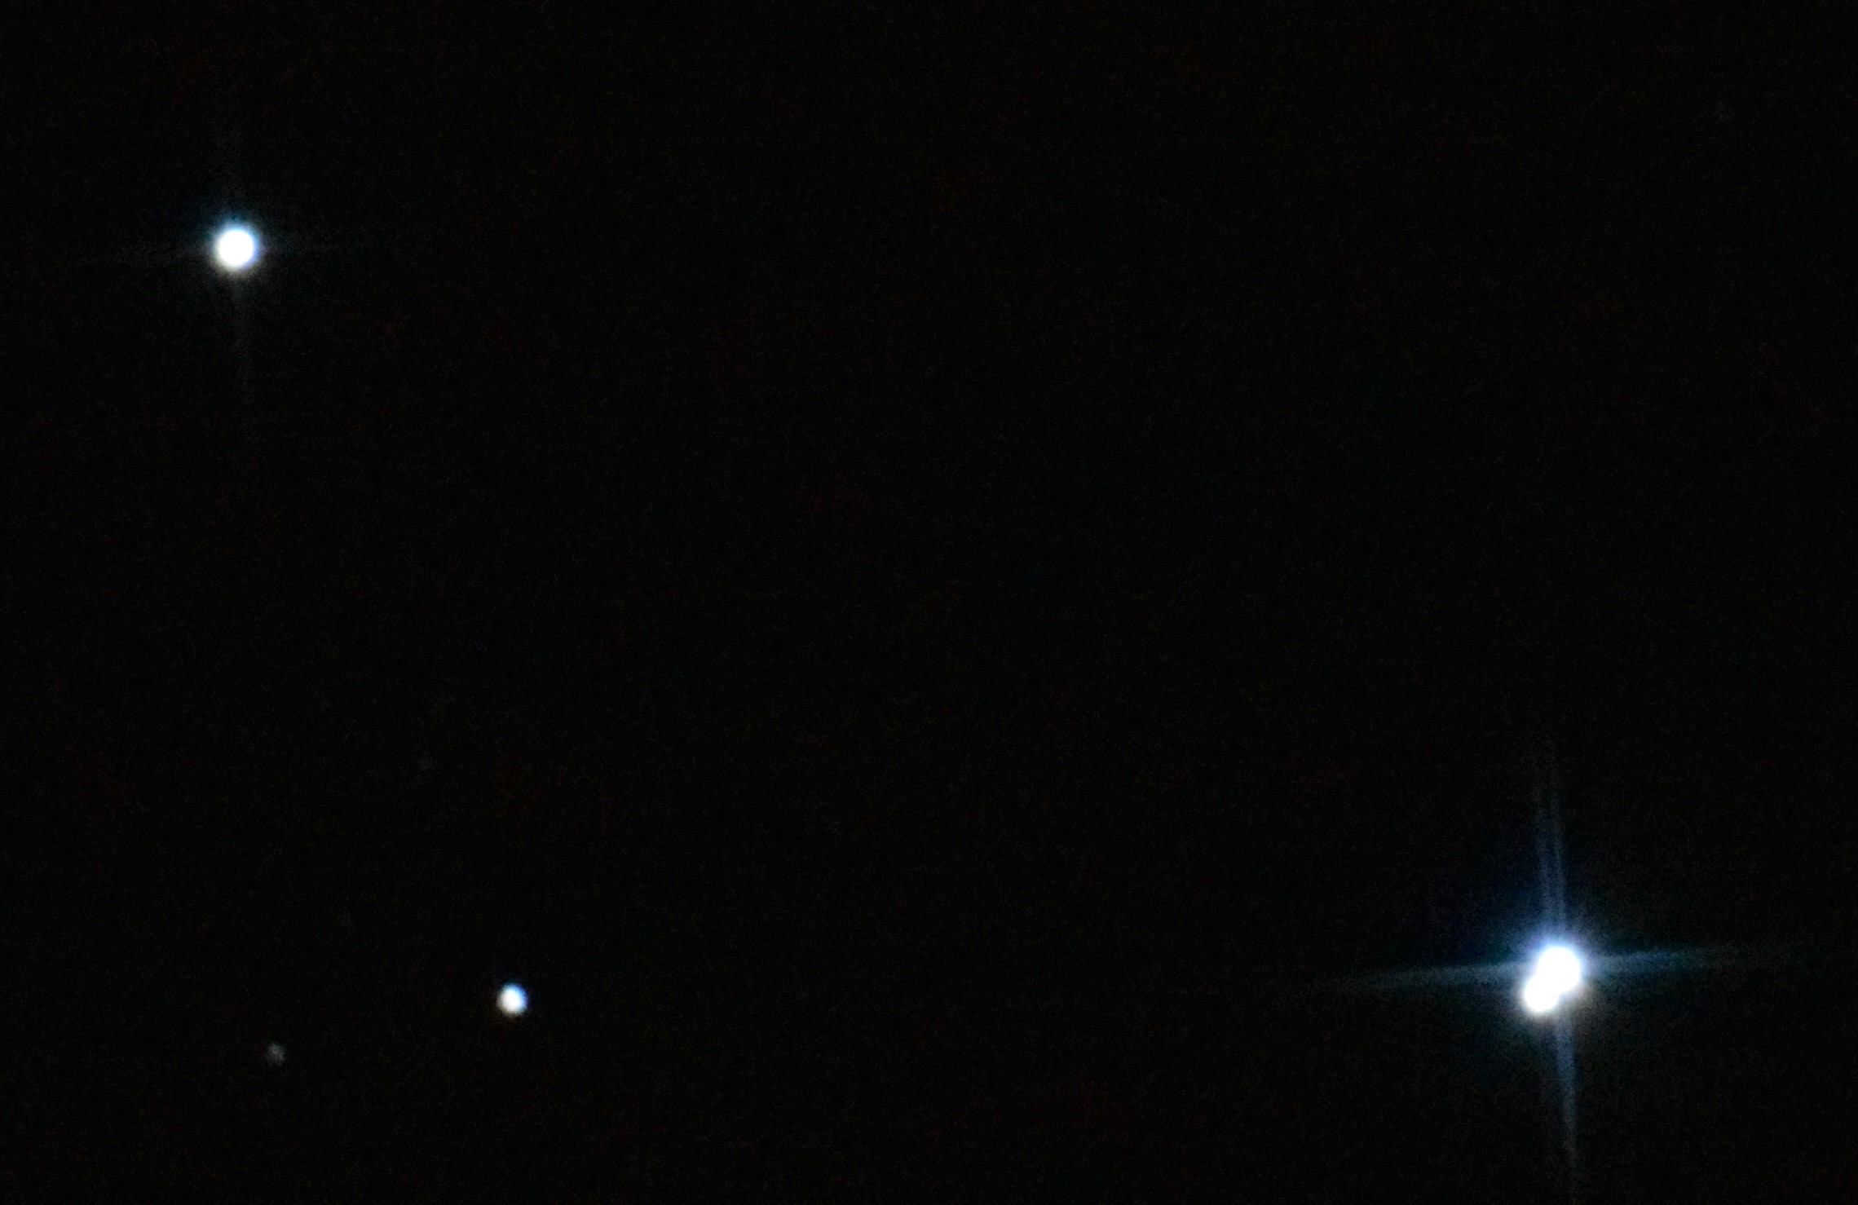

The separation of the two stars can be seen by inspection of the stars at the top left Alcor (80 Uma) and at the bottom right Mizar (ζ Uma) of these pictures. Less trailing was observed in these pictures compared to the Orion nebula pictures but this would be expected due to their higher (declination) positions.

At an exposure of 5 seconds at the 12800 ISO the reflecting telescope image starts to blur the two stars of the Mizar double into a single image. Some distinction is maintained with the lower exposures.

Three more images were taken the first two at 10 second exposure and ISO 1600 and 12800 respectively, the third image was at 12800 ISO for 25 seconds.

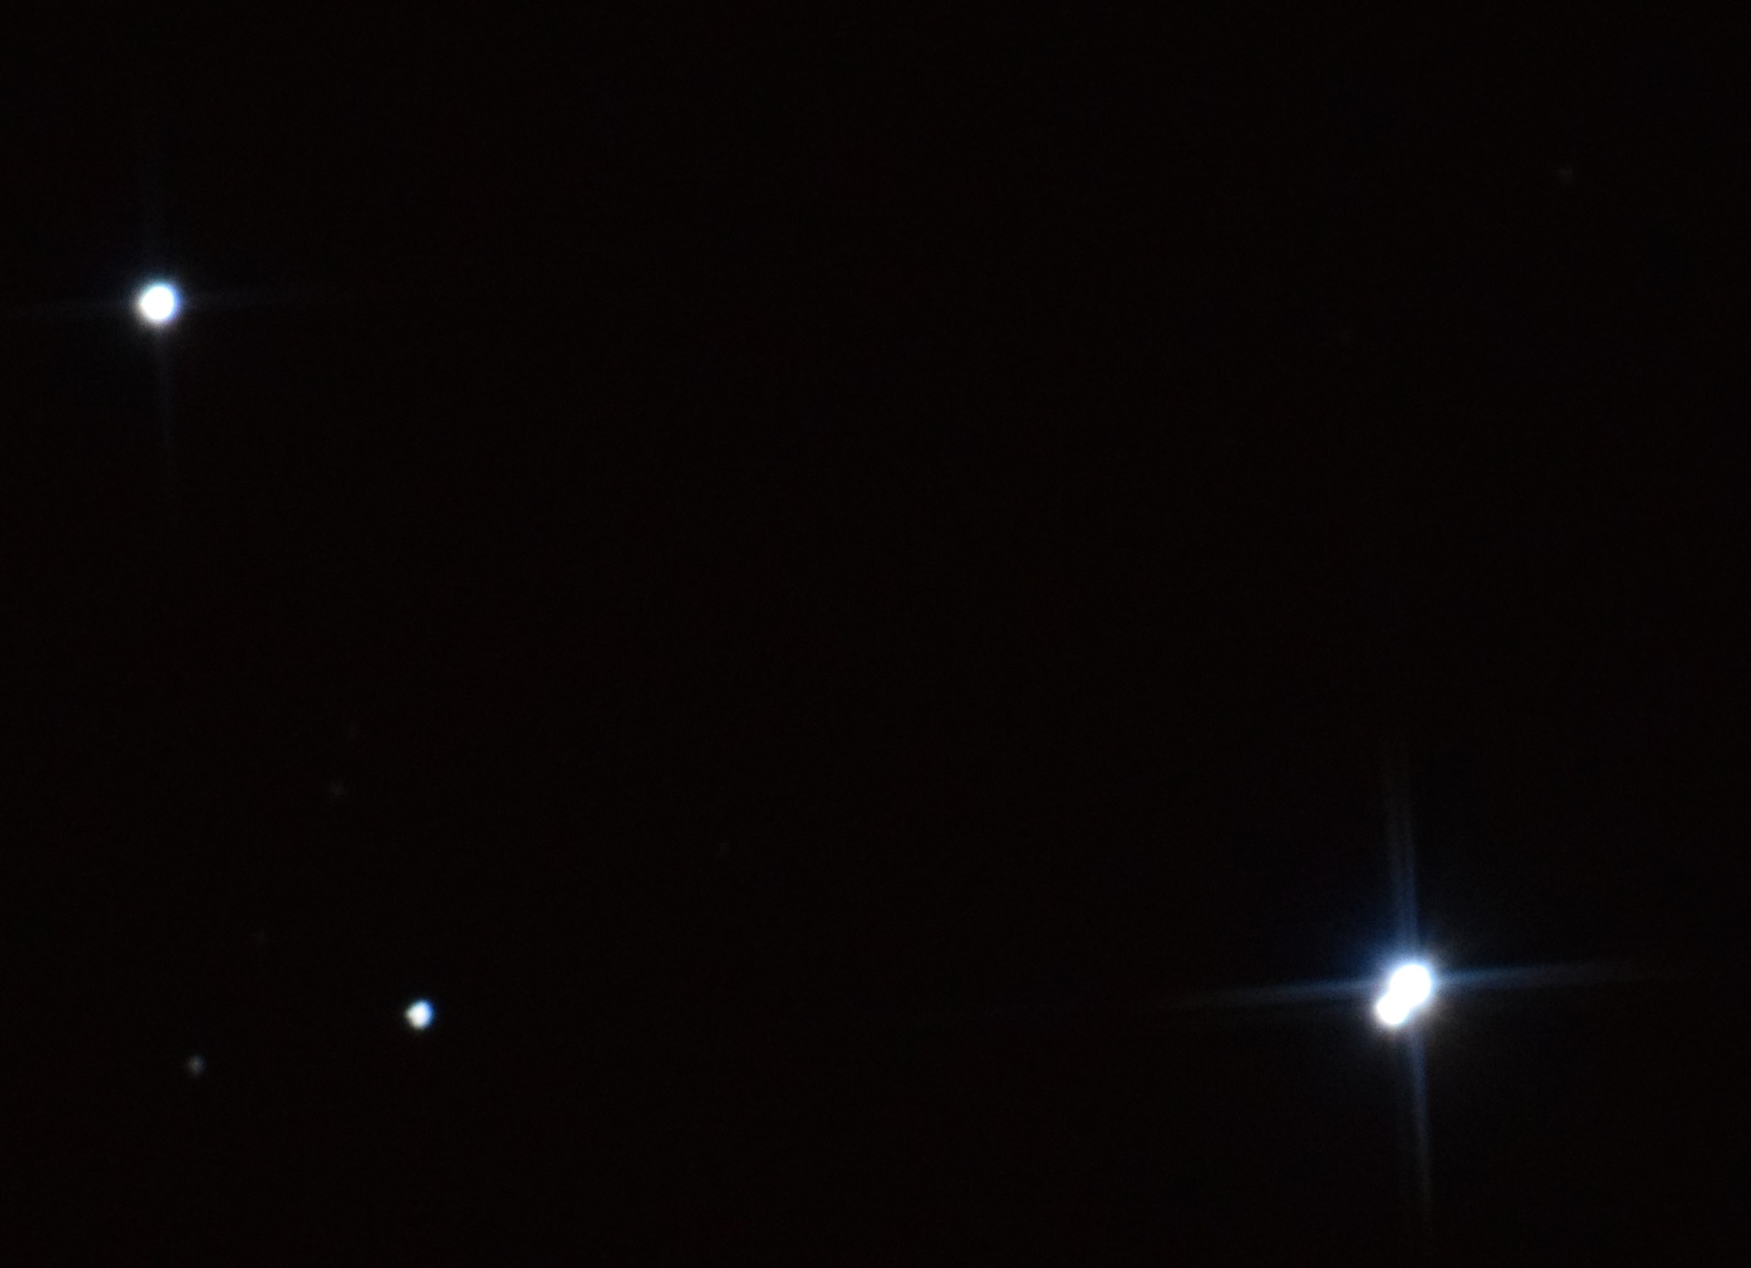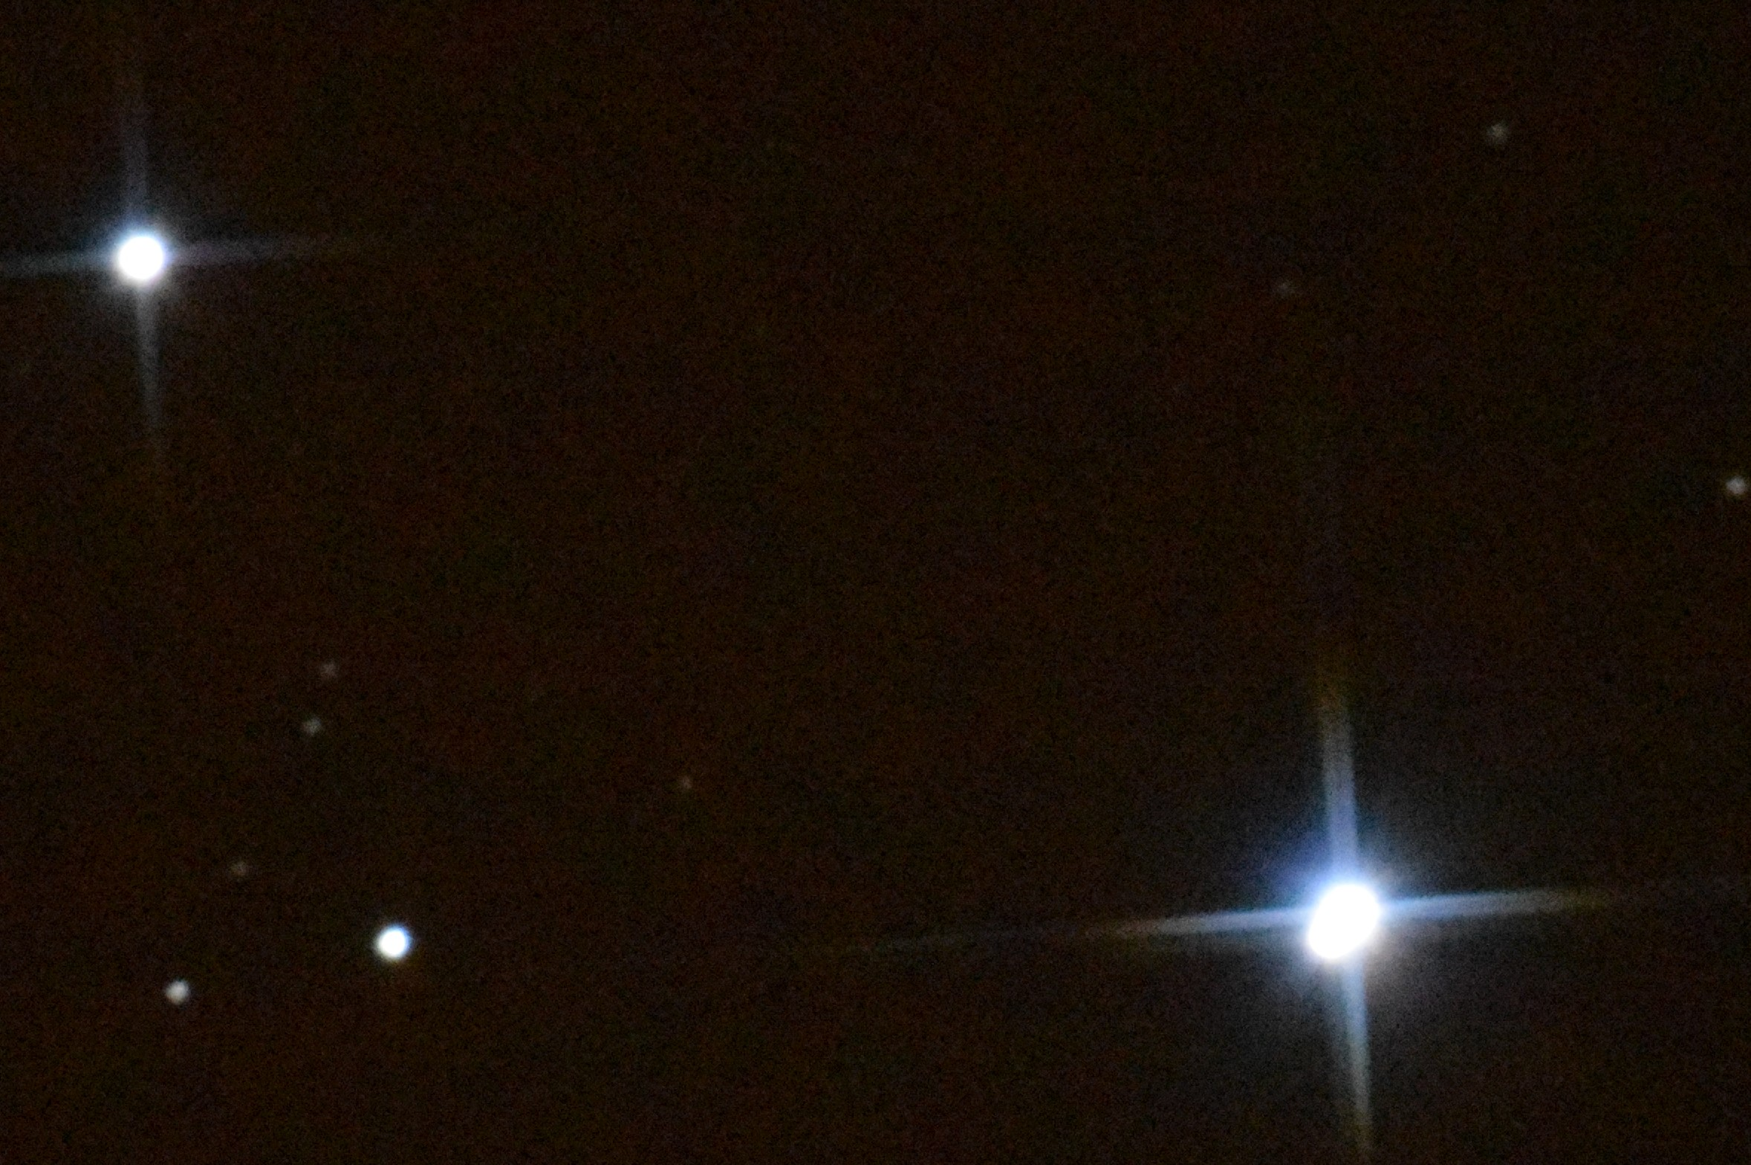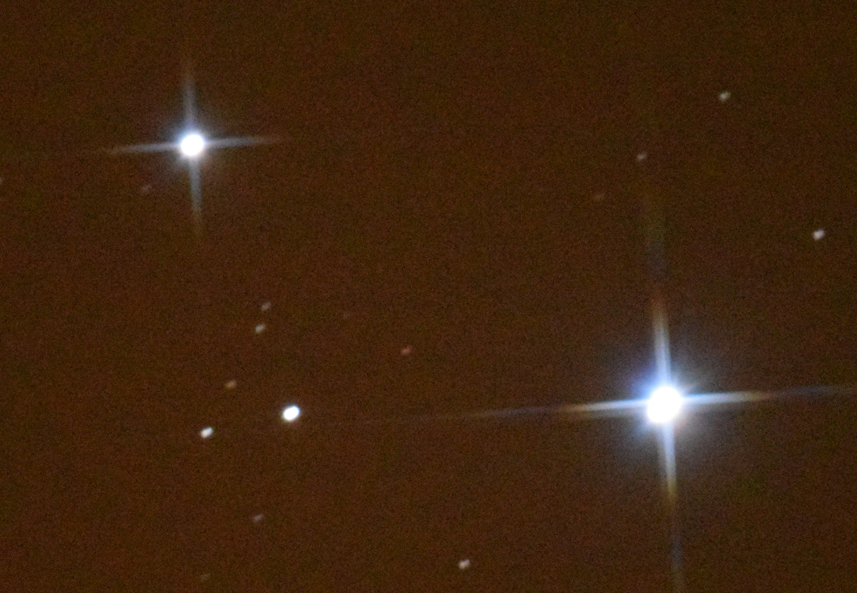

The greater exposure with the low ISO value in the first picture is very similar to the previous lower exposure but higher ISO value pictures. The second two pictures do as expected and almost lose the double star definition but do start to show some of the previously not seen background stars. The longer exposure at the high ISO value shows the red hue appearing again.

The star to the lower left of the pictures is (by literature researched) ‘Ludwig’s Star’ at magnitude 8.8, it was discovered in 1772 by astronomer Johann Liebknecht who believed he had found a new planet.

Measuring the plough star distances by angle

The telescope was packed away at around 20:30 UT, when the “sky ruler” which was taken from a ‘sky at night’ template and made by the junior astro-scouts was tested. One of the more experienced students had commented that the larger angles didn’t seem accurate. This was borne out by checking the plough.

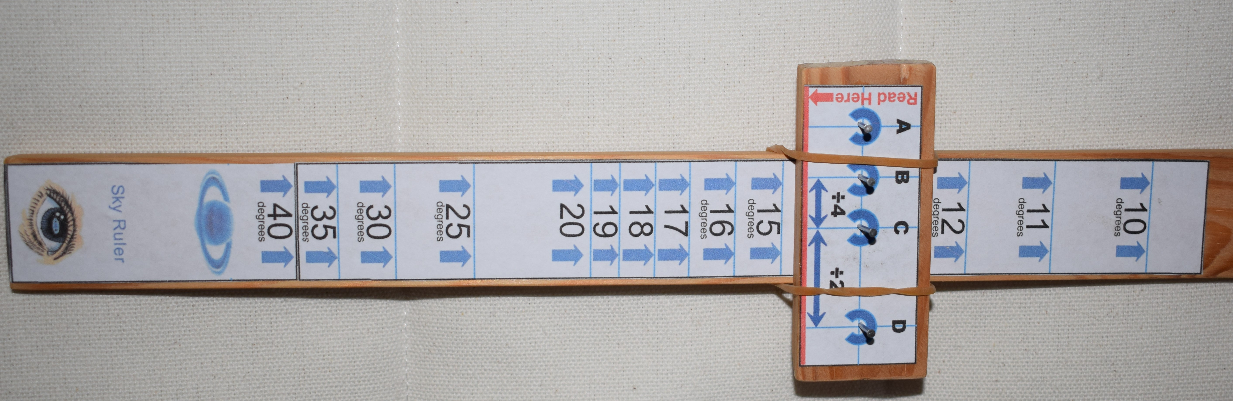

The angles measured are listed below:

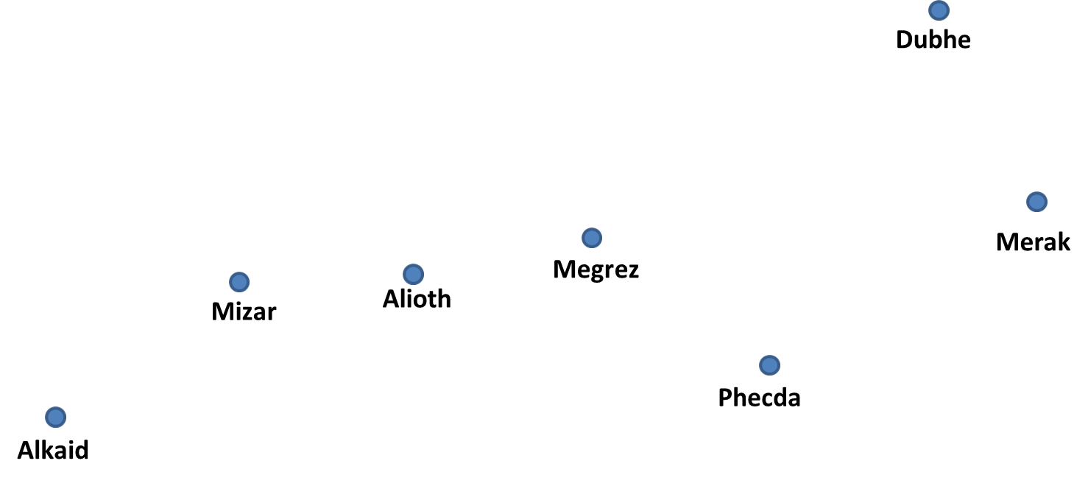

Distance Angle | Measured Value (degrees) | Given Value (degrees)
Dubhe to Merak | 6.75 | 5.5
Dubhe to Megrez | 12.0 | 10.0
Dubhe to Alkaid | 38.0 | 25.0

The larger measurement was checked several times and was always in the same “ball-park”. This is much too high. The lower measurements were still high but much closer in expected value, this may be to do with pin positioning or scale error. Overall the inaccuracy has been confirmed.

Conclusions

Experienced imagers with better equipment will probably identify the limitations and errors made in the pictures taken, however this is a learning exercise and making use of the limited and worn equipment. Further work will be carried out to determine what improvements can be made. The use of a tracking camera may help if the mount and drive system are not too badly worn and finer polar alinement should also give some improvement.

The “sky ruler” has some issues although the principle is sound, a larger version will be produced with the dimensions calculated from scratch. A better made astrolabe may produce more accurate results, however for simplicity with the intent of being able to produce a non-complicated instrument suitable for the very young to make within an hour the “sky ruler”, or cross-staff to provide the correct term, is worth a little more development time.

Report Compiled by Andy Anning
Astronomy Report For | Personal fun development | No of Pages | 3

