Date | 25th June 2018 | Time | 10:00 to 12:00 BST
Weather | Clear | Seeing - Antoniadi Scale | III
Location | Back Garden looking south (Lat N50 42’, Long W3 4’)
Bortle Scale | 6
Instrument (s) | Skywatcher 150 reflector, EQ5 mount with drive  Pictures Nikon D3300 body fitted to telescope using a 2X Barlow Lens.

Report

Observing Conditions

Clear sky, Moon almost full (3 days to full Moon on 28th June) so light sky. Two street lights close by and house and security lights also on during session. Main constellations visible towards end of session around 11:30 BST.

Purpose of Session (Plus equipment details)

To investigate the use of the Barlow lens on the D3300 and telescope and picture Saturn. The DSLR camera was set to Raw + JPEG, ISO and exposures varied throughout the night, The remote was not working so some blurring occurred with camera shake, also automatic noise reduction was still on which affected some results, comparison of the RAW and JPEG images show this. The telescope tracking was not exact as star trails appear on above 10 second exposures. These are items to assess before next session.

Observed the following

Moon

Started with the Moon which was nearly full, other stars not visible naked eye, only other sky object visible was Jupiter. Checked telescope viewing on Moon with 25mm eyepiece and clear bright images seen. Initial attempts at using the Camera fitted to the telescope with the Barlow lens proved only blurred images in live view setting.

Some viewing then done using the 10mm eyepiece, good detail but too bright to view for long. Need to reduce light levels using telescope cap openings or a Moon filter in future for the Moon.

After viewing Jupiter and Saturn (discussed below) a second try at imaging the Moon using the Barlow lens met with success, what the difference was is unknown. The three images show what is possible without too much effort, however finer focusing and further work on exposure settings would have improved results.

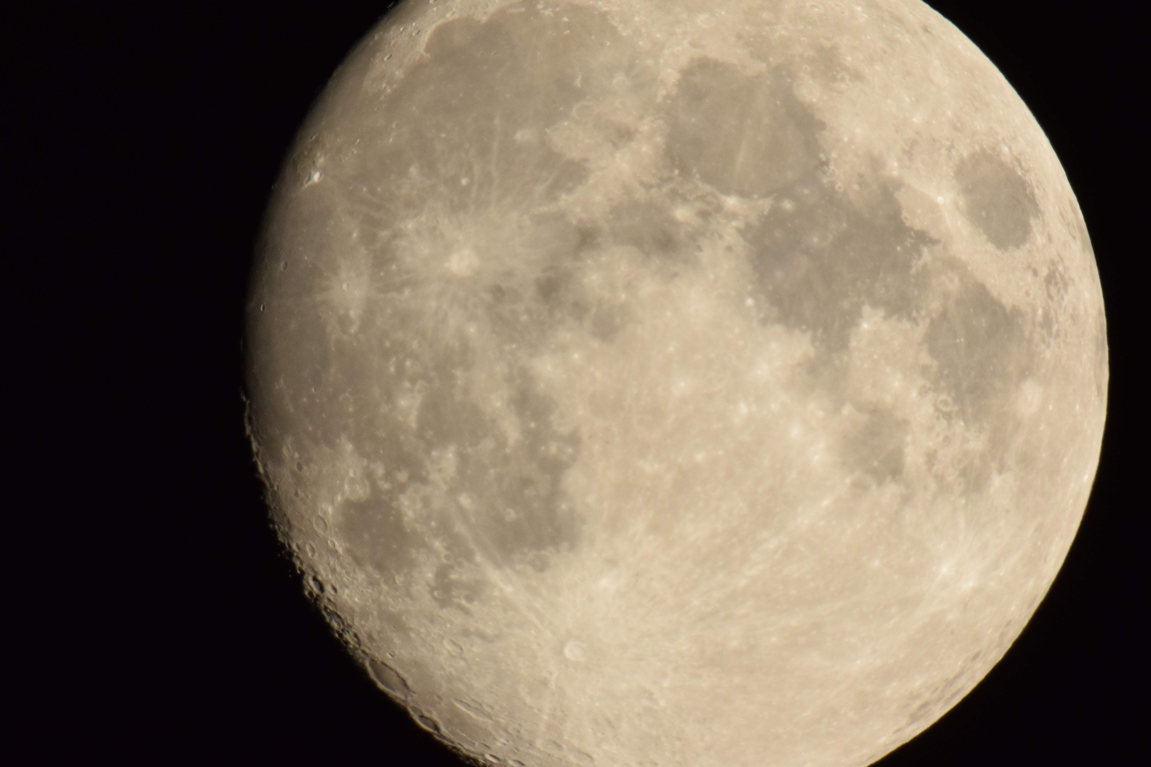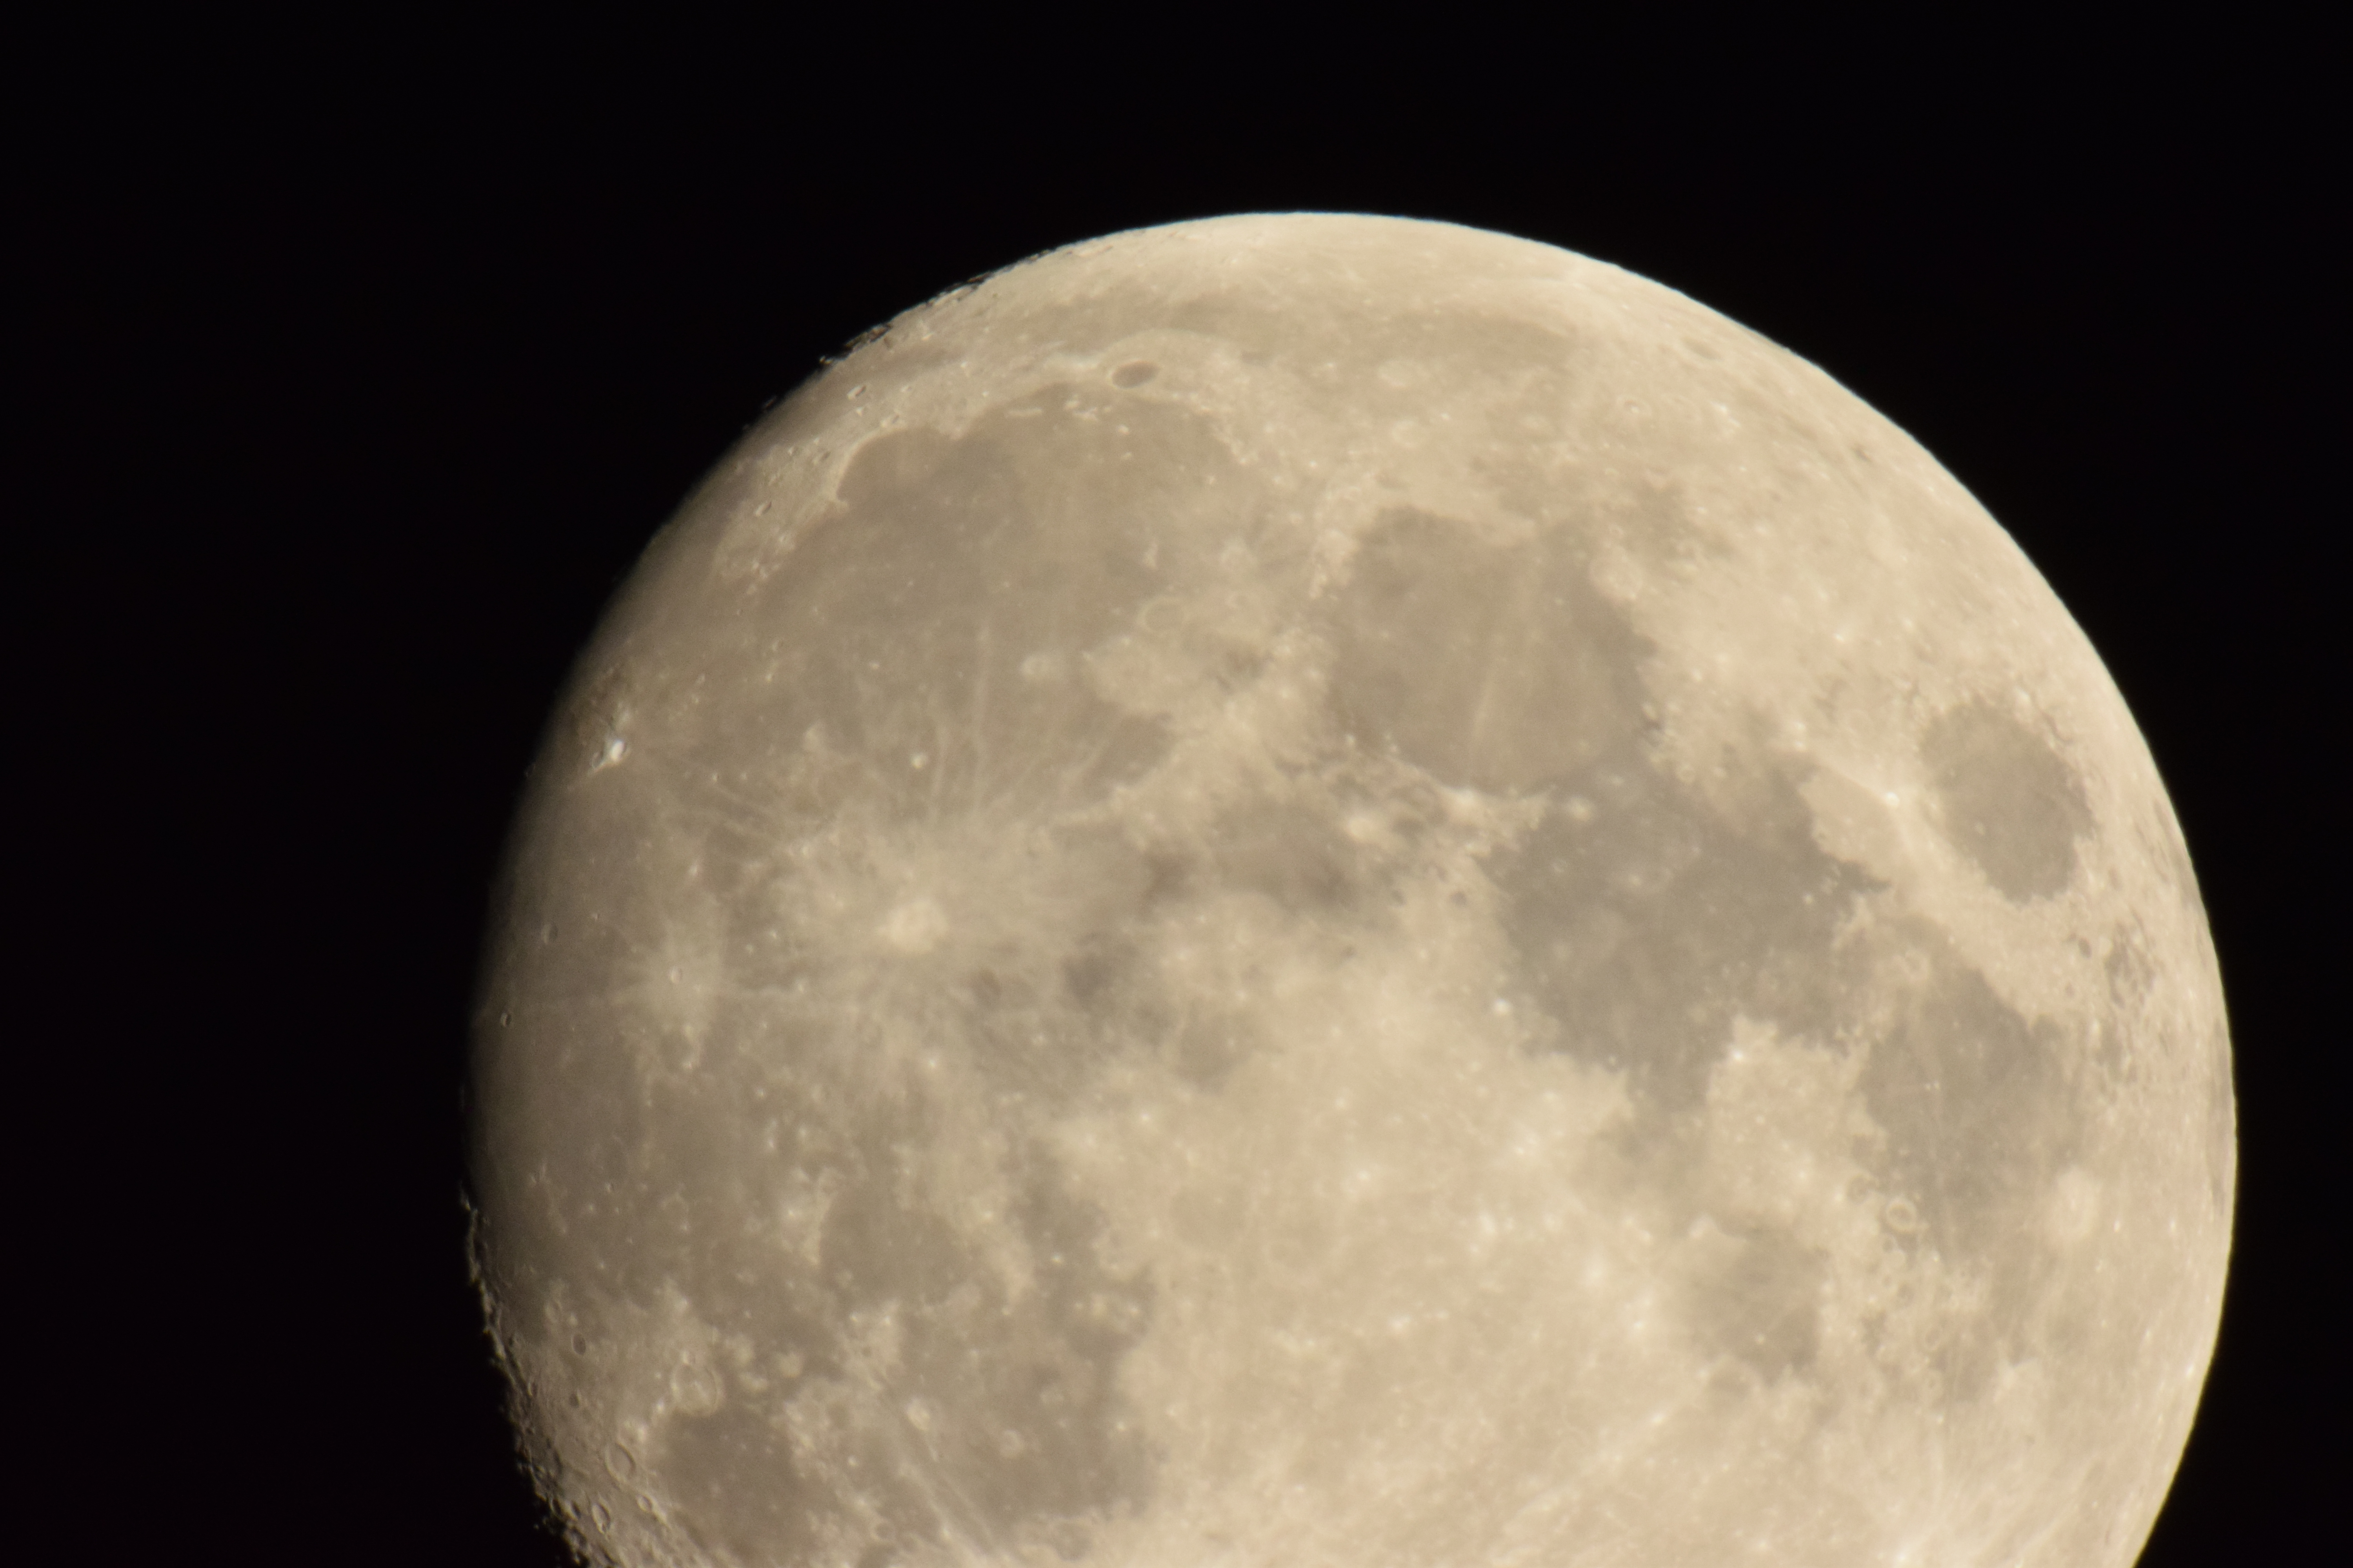
23:19 – 1/400 sec –ISO 1600

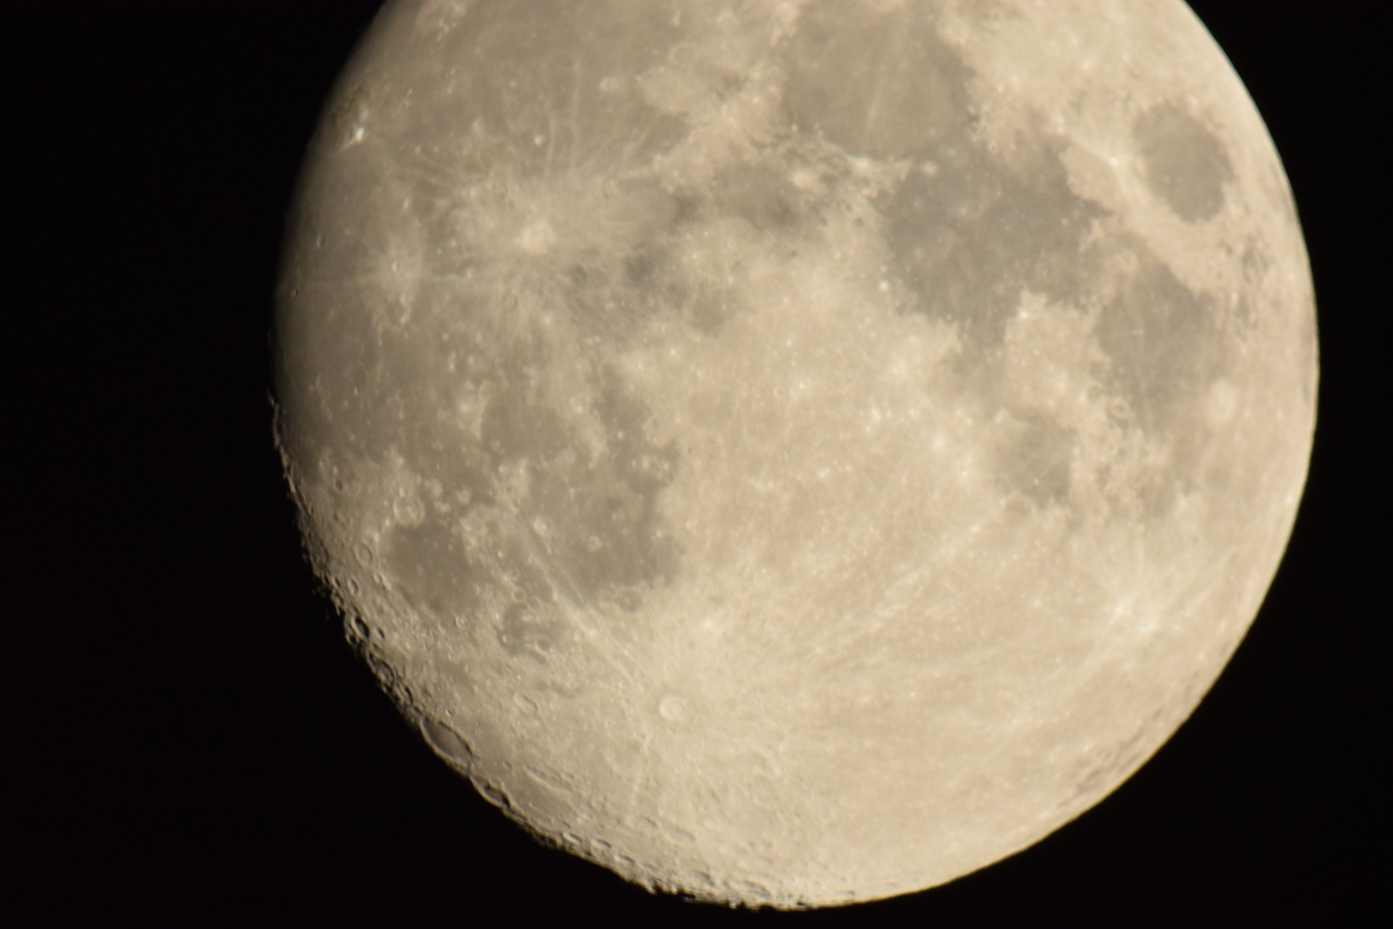
23:22 – 1/400 sec –ISO 1600

Jupiter

As initial attempts at imaging the Moon did not meet with success attention was turned to Jupiter as an easy target. Achieving correct exposure and ISO sensitivity does need improvement, however some images where obtained. In the 10mm eyepiece the major cloud formations on Jupiter could be clearly seen, but this could not be reproduced using the camera.

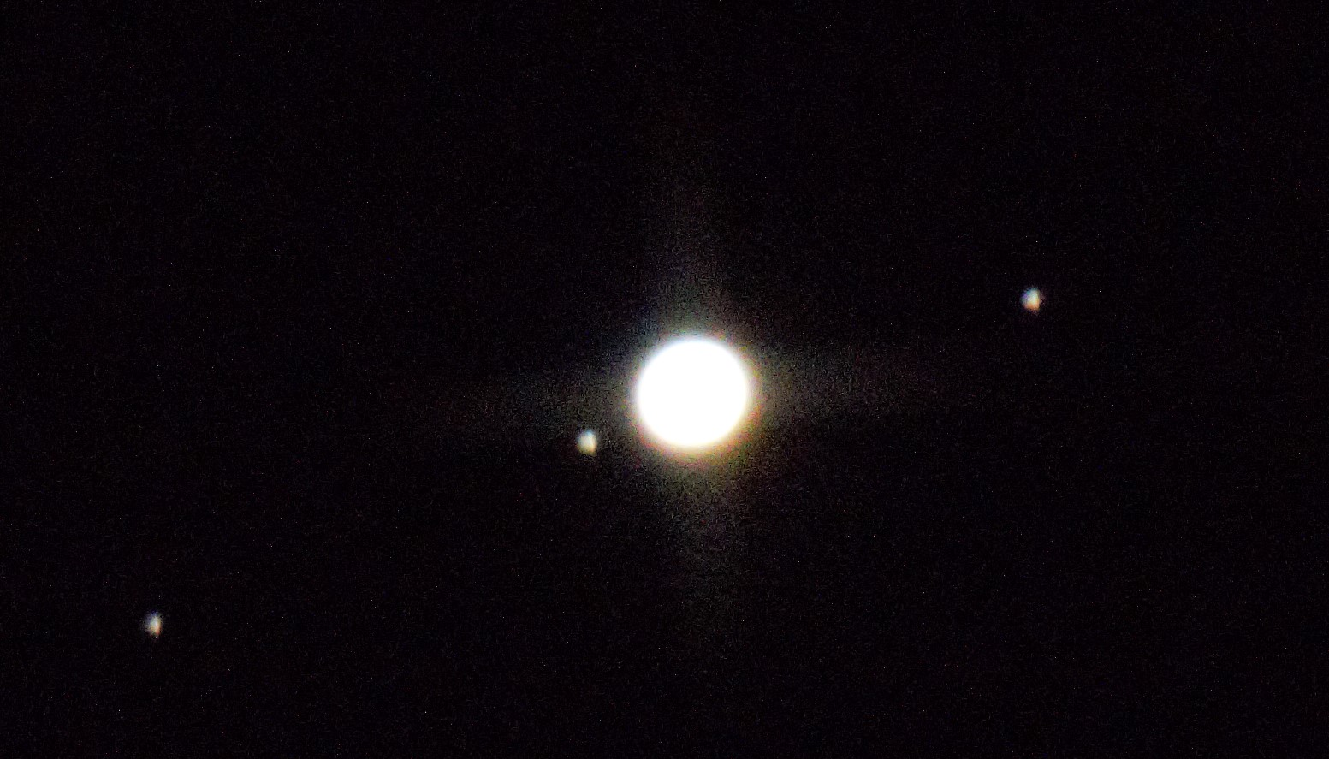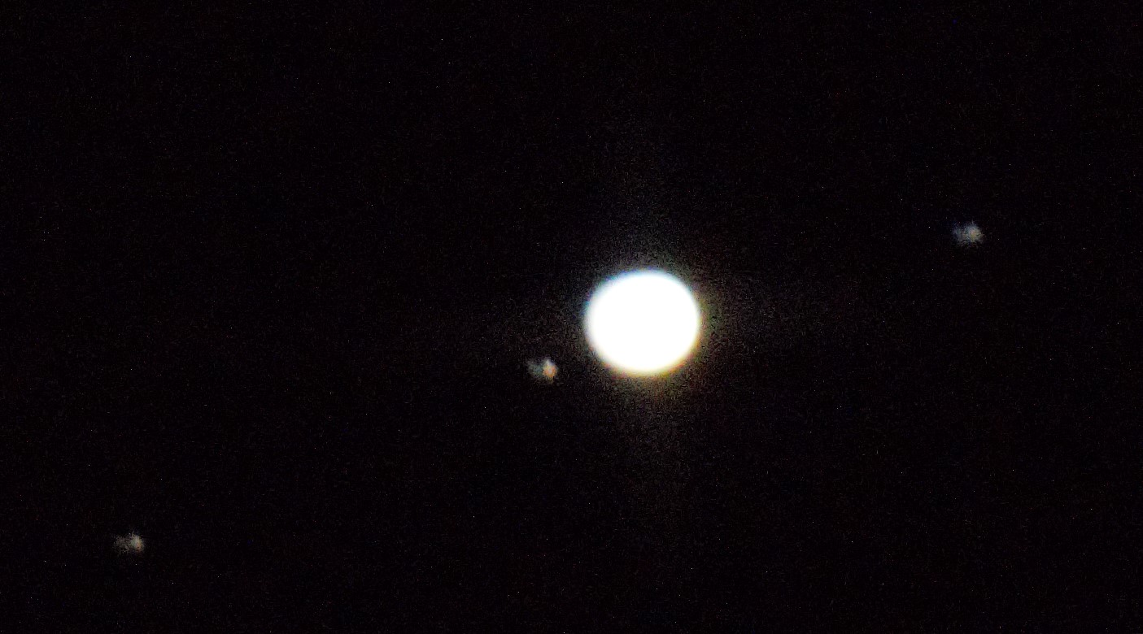
22:48 – 1/10 sec – ISO 12500 22:50 – 1/20 sec – ISO 12500

Saturn

Saturn was a faint point very low on the horizon from this location. Viewing using the Barlow lens and 10 mm eyepiece showed the shape of the planet with a clear gap between the planet and rings. There was insufficient definition to see any detail or Cassini gap in the rings. The image is relatively poor but at least it shows the shape of a planet with a fuzz ring set.

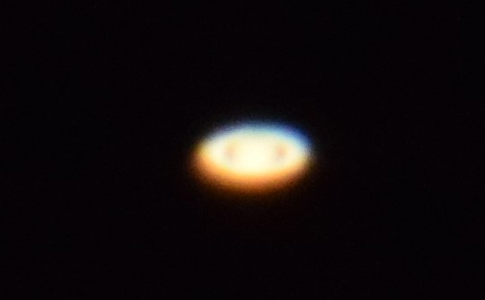
23:06 – 1/5 sec – ISO 1600

Possible shooting star (or aircraft)

While experimenting with exposures away from the Moon and planets the following image was obtained using a 10 second exposure. The area of the sky was around Serpens Cauda and Aquila at 11:29 BST, but was not specifically pointed at the time.

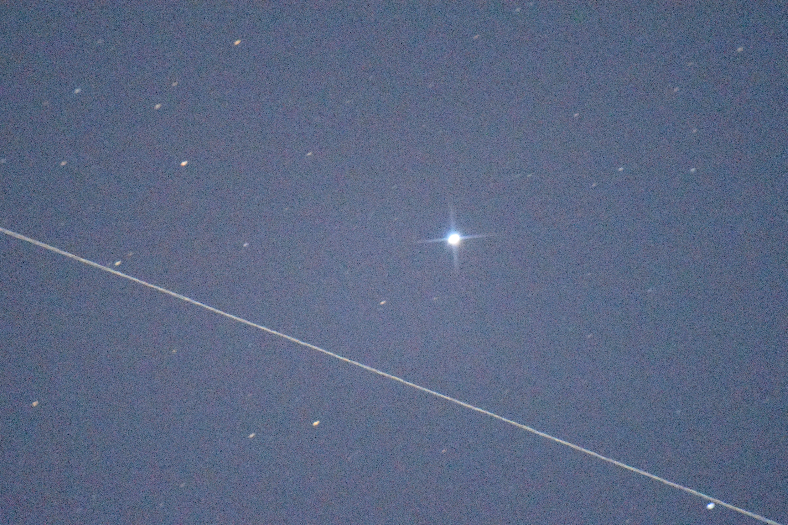
23:29 – 10 sec –ISO 2500

Cassiopeia & Mizar

Towards the end of the session a quick look at both Cassiopeia and the area near Mizar in Ursa Major were viewed. The viewing was not particularly good but the main constellation shapes were easily visible. The two images were somewhat undefined but are to experiment with darks taken at the same time period.

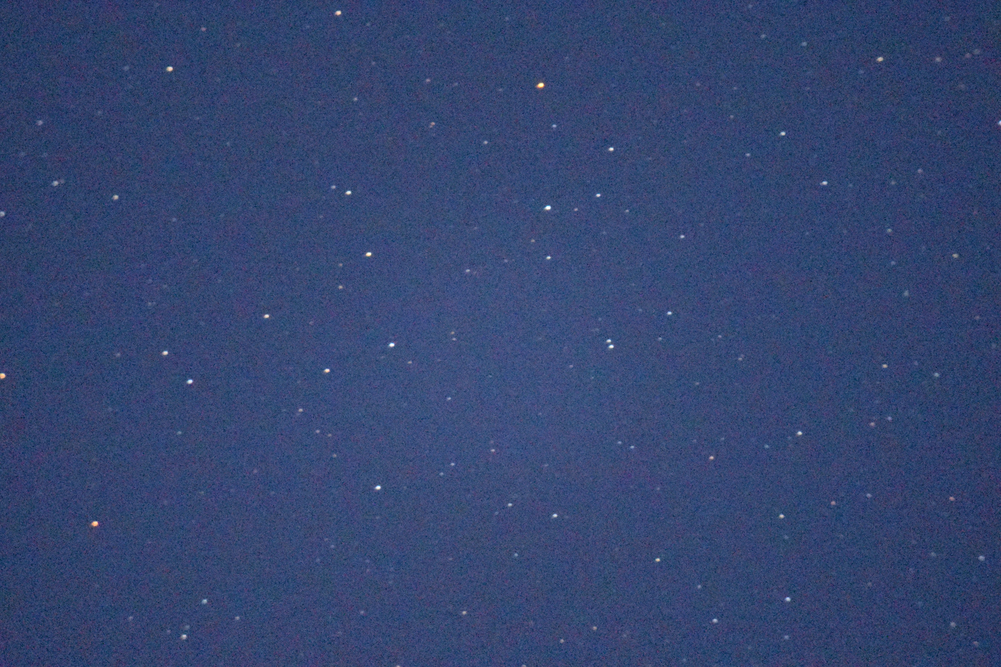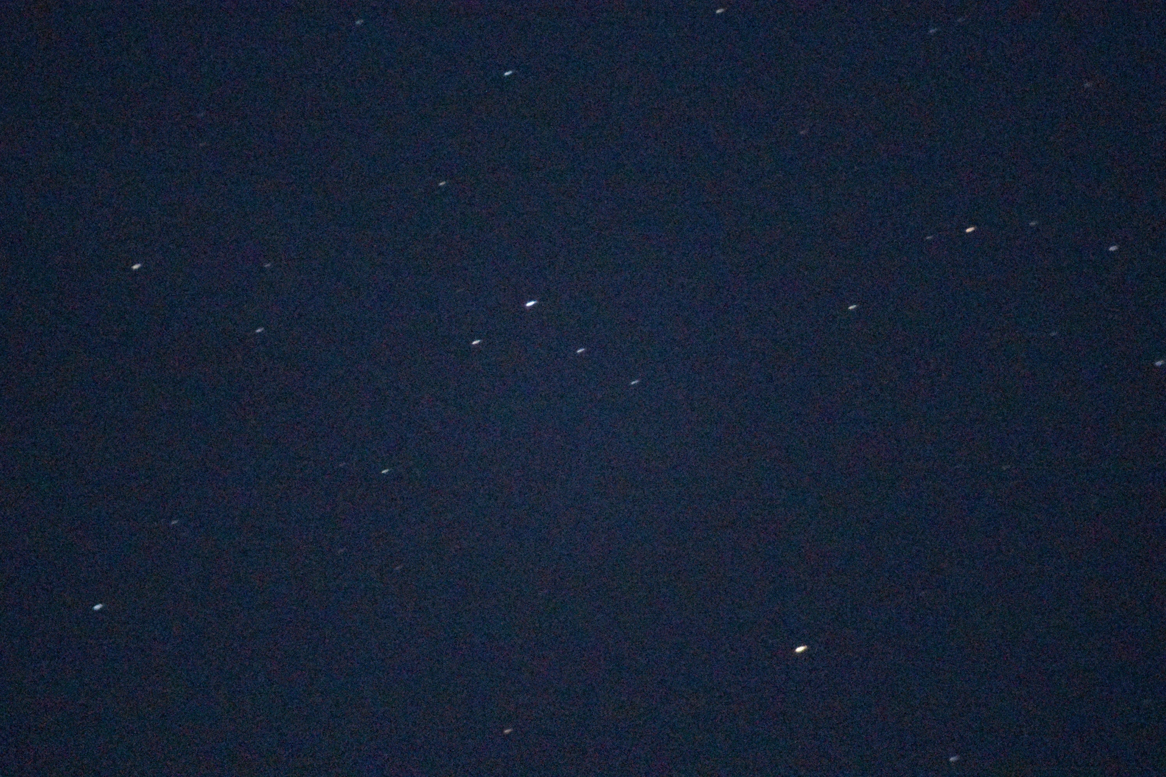
23:32 BST – 10 sec –ISO 2500 23:35 BST – 10 sec – ISO 2500

Results and Conclusions

Mixed achievements, still a long way to go with the imaging, but at least the camera is functioning with the Barlow lens attached as the optics into the 1.25” eyepiece mount. Need to now work on missing elements and build up experience on specific targets rather than moving around.

However I was very pleased to see Saturn through the scope and obtain some evidence that I actually found it.

Report Compiled by Andy Anning 25th June 2018
Astronomy Report For | Astrophotography skill development | Number of Pages | 4

