Date | 20th April 2018 | Time | 21:05 BST
Weather | Warm, Clear | Seeing - Antoniadi Scale | III – Typical Seeing
Location | Norman Lockyer Observatory, Sidmouth  52.72 Deg North 3.52 Deg West
Bortle Scale | Class 3 – Rural Sky Limiting Magnitude 6.6 to 7.0
Instrument (s) | 6.25 in Refractor “The Lockyer”

Report

Observing Conditions

- Clear, Warm
- Moon First Quarter
- Good seeing

Observed the Following – with the 6.25 inch Refractor

- Moon – Mare Crisium
- Moon – Mare Fecunditatis
- Moon – crater Macrobius
- M44 NGC2632 Open Cluster Cancer II2m
- M67 NGC2682 Open Cluster Cancer
- NGC2841 Galaxy Ursa Major
- M3 NGC5272 Globular Cluster Canes Venatici
- Double Star Ursa Major Mizar & Alcor

Notes

- Very attractive grouping in a line of the Moon, Aldebarran and Venus
- 21:50 BST The evening session started with a look at the Moon. It did not disappoint, Mare Crisium and Mare Fecunditatis looked superb. There were a number of interesting craters on the terminator however identifying these craters has proved difficult.
- 22:05 BST Next up was the open cluster M44 more commonly known as “The Beehive” or “Presepae”. This is an attractive grouping of stars but suffered badly from the narrow field of view offered by the eyepiece. To understand this cluster in context with its surrounding it really needs to be viewed through binoculars or a widefield telescope.
- 22:15 BST We now turned the telescope on M67 another open cluster in Cancer. IN my opinion this is the more satisfying cluster of the two. It is more compact and even through this 6 inch telescope there was the faint glow of unresolved stars. The cluster stands out well from its background which makes it easy to see where it starts and ends.
- 22:30 BST Now for a real challenge. This telescope has no goto function it was basically down to using Stellarium and a bit of star hopping to find this one Galaxy NGC2841 in Ursa Major. Ok it was a fuzzy blob, there was the hint of a star core with a hazy outer region. Apparently this is considered one of the finest objects in the Herschel catalogue, I think we may need to use the big 14 inch Dobsonian telescope on this next time.

Astronomy Report For | Friday 20th April 2018 | Page | 1 of 2

Notes continued,

- 22:45 BST And now for a complete change the Globular cluster M3 in Canes Venatici Class VI which basically means it has a reasonably compact core. This was a very nice sight indeed the more time spent at the eyepiece meant that more stars were resolved. The was no doubting the nature of this object and after a while a pale yellow colour could be discerned as well as some structure.
- 22:55 BST Finally we finished with a look at the Double star Mizar/Alcor in the constellation of Ursa Major. The telescope easily revealed that Mizar does in fact have another companion.
- Session finished at 23:05 BST

Report compiled by David Alexander

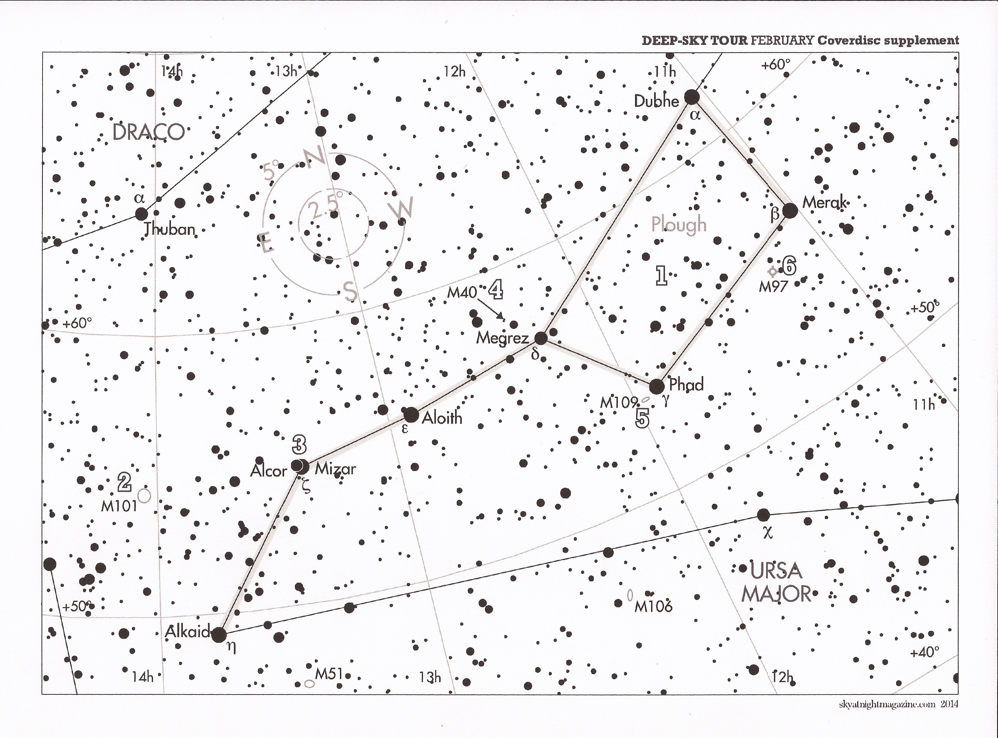

Chart showing Mizar/Alcor and Mizar’s companion.

Astronomy Report For | Friday 20th April 2018 | Page | 2 of 2

